# Sports Tourism Program

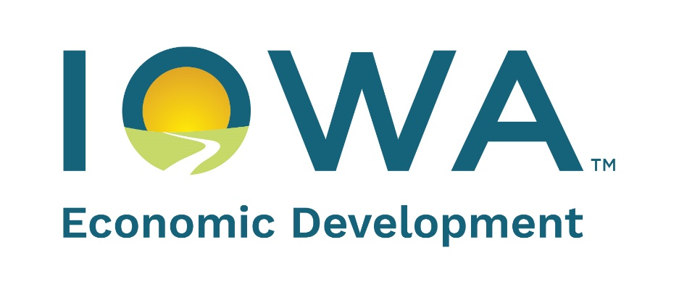

**FY2025**

**V 10/24**

**Purpose**: Provide financial assistance for projects that market or promote sporting events in Iowa.

**Eligibility**: Cities, counties, Iowa not-for-profit economic development organizations or other Iowa not-for-profit organizations including those that sponsor or support sporting events are eligible to apply for assistance of up to 50% of the eligible cost to actively promote or market an eligible sporting event. Eligible applicants can apply jointly. Examples of eligible expenses include: payments to vendors, advertising, equipment rental, promotional materials and costs related to production of promotional materials. Examples of ineligible expenses include: bid fees; rights fees; solicitation efforts or lobbying fees; travel costs of applicant staff, meals, dining or alcoholic beverages; items that are purchased for resale; prizes given to participants; costs related to infrastructure or ongoing costs of a facility; event production and operational costs and expenses incurred prior to the Enhance Iowa Board approval.

Award recipient must incur all proposed project costs directly. Eligible project costs will be documented with invoices. Invoices directed to or paid by another entity will be disqualified.

A convention and visitors bureau (CVB) is an eligible applicant, unless the entity has received financial assistance under the Regional Sports Authority Program in the same fiscal year.

Eligible sporting events include professional, collegiate and amateur level sporting events that occur in Iowa. Promotion/marketing activity can occur for up to two years. Awards cannot exceed $500,000 or 50% of the total marketing/promotion budget. Matching funds must be identified and documented. Matching funds can be provided from city, county or private sources. State funds cannot be used to match the Sports Tourism grant.

Application/approval process: Applications will be accepted on an ongoing basis, beginning November 1, 2024 until program funds are fully allocated. Project will be scored by the Sports Tourism Committee and awards will be considered during the Iowa Economic Development Board meeting the following month, if no questions are posed by Board members or IEDA staff. Faxed or mailed applications will not be accepted.

**Scoring:** The Sports Tourism Committee will review, score and make award recommendations. An average score of 75 points is required for a grant to be awarded but does not guarantee funding. The Committee will consider the following factors in scoring:

* The impact of the project on local, regional and statewide economies and the potential to attract Iowans and out-of-state visitors. Economic impact will be measured by hotel room nights generated by the event. Maximum score - 30
* The extent to which the sporting event to be promoted/marketed is unique, innovative or diverse. Projects that promote/market a new event will receive a higher score. Maximum score - 30
* Quality, size and scope of the project and the amount of positive advertising or media coverage the project generates. Maximum score - 20
* Leverage or ratio of public-to-private investment and local support demonstrated. Maximum score - 20

**Disbursement:** Grant funds will be disbursed as a reimbursement based on eligible expenses incurred within the contract dates. The applicant must incur all proposed expenses.

**APPLICANT INFORMATION:**

**Applicant Name:**

**Applicant Address:**

**City:** **Zip Code: County:**

**Applicant Contact Name: Phone:**

**Email Address: Organization Type:**

**Co-Applicant Name:**

**Co-Applicant Address:**

**City: Zip Code: County:**

**Co-Applicant Contact Name: Phone:**

**Email Address: Organization Type:**

**PROJECT INFORMATION:**

**Event Name:**

**What is the date of the proposed sporting event?**

***(****Application must be submitted to IEDA at least 90 days prior to the scheduled event****)***

**Is this event new?**

**If no, please answer the following questions:**

**When was the event previously held?**

**Please provide a detailed explanation of how the proposed event will be different from previous events.**

**Describe the sporting event:**

**Describe in detail** **the proposed marketing and promotion campaign for this event. For repeat events, please describe the new marketing/promotion effort:**

**Describe how the proposed marketing and promotion was developed, including any internal or external expertise that was utilized, research, or previous relevant experience with similar events.**

**Detail how the proposed marketing/promotion is unique, innovative and/or diverse:**

**Who is the target audience for this event?**

**Please detail how the marketing/promotion will attract visitors within the target audience to attend the event. What is the geographical reach of this campaign?**

**What is the proposed timeline for the marketing/promotion?**

**Project Request Amount:**

*Request cannot exceed 50% of total promotional expenditures included in application. Request cannot exceed $500,000.*

**Promotion Budget:** Examples of eligible expenses include: payments to vendors, advertising, equipment rental, promotional materials and cost related to the production of promotional materials. All costs must be directly related to marketing and promotion of the event.

Examples of ineligible expenses include: bid fees; rights fees; solicitation efforts or lobbying fees; travel costs of applicant staff, meals, dining or alcoholic beverages; items that are purchased for resale; prizes given to participants; costs related to infrastructure or ongoing costs of a facility; and expenses incurred prior to IEDA Board approval.

Existing Events: Only expenses relating to new marketing or promotion for the event are eligible. Do not include costs for marketing and promotion that was completed with prior events.

|  |  |  |  |
| --- | --- | --- | --- |
| **Source of Funds** |  | **Use of Funds** |  |
| **IEDA** | **$** |  |  |
|  |  |  |  |
|  |  |  |  |
|  |  |  |  |
|  |  |  |  |
| **Total** | **$** | **Total** | **$** |

**\*\**Source of Funds and Use of Funds Columns should be equal.***

**Please detail how each “*Use of Funds”* listed above relates to the marketing and promotion campaign for this event.**

**ECONOMIC IMPACT:**

**What is the estimated number of spectators for the event? (For new events, please describe how the estimate was generated; for repeat events, please include spectator data from prior years)**

**Describe how the proposed event and marketing/promotion activity will increase overnight hotel stays in the area:**

**How much revenue will be generated from ticket sales for this event?**

**Economic impact will be determined by estimating the number of hotel room nights generated by the proposed sporting event and multiplying the number of estimated hotel room nights by the Average Daily Room (ADR) rate for Iowa hotels. Use the chart below to estimate the number of hotel nights generated. The sheet will automatically apply the ADR of $95.62* to calculate the total estimated economic impact.**

**\*$95.62 ADR is based on 2019 numbers**



**Other than the overnight hotel room calculation described above, explain any other economic impacts expected from the project. Is the impact local, regional or statewide?**

**Why is your community uniquely situated to host this event? Does it enhance other events or attractions in your community?**

**Does your organization have/support any initiatives or policies related to diversity, equity and inclusion (DE&I) that are geared towards attracting diverse audiences to the state? If so, how have they influenced the development of this project?**

**Acknowledgment, Release of Information, & Certification**

1. In the last five years, have there been any judgments or court actions completed or are any judgments or court actions currently pending against the applicant entity?

Yes  No   If yes, please explain.

2. In the last five years, has any current director or principal officer(s) been accused or convicted of any wrongdoing or crime in their capacity as director/principal officer?  Yes  No   If yes, please explain

3. Have there been any current or past bankruptcies on the part of the applicant entity?

Yes  No  If yes, please explain

4. In the last five years, have there been, or are there currently any investigations of potential violations of public health, safety or environmental laws by the applicant entity?  Yes  No   If yes, please explain

I acknowledge that I have read and understand the application materials and administrative rules including the provisions relating to security and contracts as noted above. Further, I give permission to the Enhance Iowa Board or the Iowa Economic Development Authority (IEDA) to perform due diligence, perform credit checks, contact the organization’s financial institutions, and perform other related activities necessary for reasonable evaluation of this proposal. I understand that all information submitted relating to this application is a public record. I certify that all representations, warranties, or statements made or furnished in connection with this application are true and correct in all material respects. I understand that it is a criminal violation under Iowa law to engage in deception and knowingly make, or cause to be made, directly or indirectly, a false statement in writing for procuring economic development assistance from a state agency or subdivision.

Signature of applicant certifying officer or individual:

Date:

Signature of co-applicant certifying officer or individual:

Date:

**ATTACHMENTS:**

1. **Documentation of matching funds (required)**
2. **W-9 (required)**