

CERTIFICATION PORTAL (CP) USER GUIDE
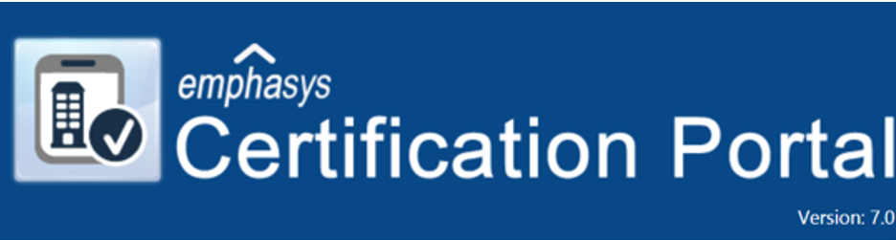
Formally known as: Certification Online (COL)

January 2025

Table of Contents

SECTION 1 | Logging in | Page 3
SECTION 2 | Accessing Projects | Page 6
SECTION 3 | Manual Entry - New Move In | Page 9
SECTION 4 | Manual Entry - Recertification | Page 17
SECTION 5 | Manual Entry – Transfer | Page 23
SECTION 6 | Manual Entry – Move Out | Page 27
SECTION 7 | Third Party XML Tenant Data Upload | Page 28
SECTION 8 | Document Upload | Page 31
SECTION 9 | Annual Certification | Page 33
SECTION 10 | Reviewing and Submitting Data | Page 34
SECTION 11 | Management Controls & User Access | Page 36

SECTION 1

LOGGING IN

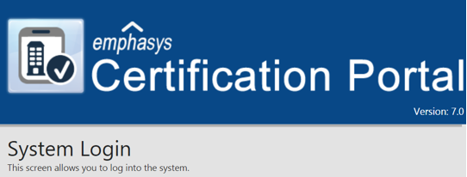

New (Super) User
If you are a new user who will have full control (Super User) of the CP, contact IFA for a User ID and Password.

New Non-Super User
If you are a new user assigned by the Super User, the Super User will set up your User ID, Password and assign specific projects to you. Contact your Super-User for set-up and login credentials.

New super and non-super users will login using the IFA issued temporary User ID and Password at the System Login page.
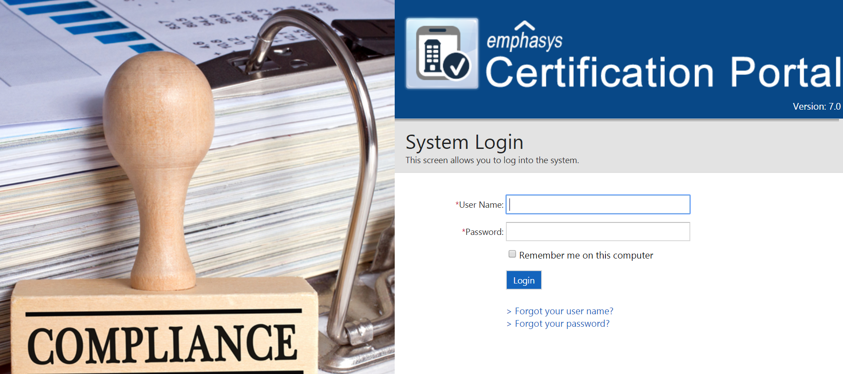

New Users will be required to create a new User ID and Password. This is also the case when IFA resets a Super-user login and password.

NOTE: The username and password fields require at least 6 characters and are case sensitive.

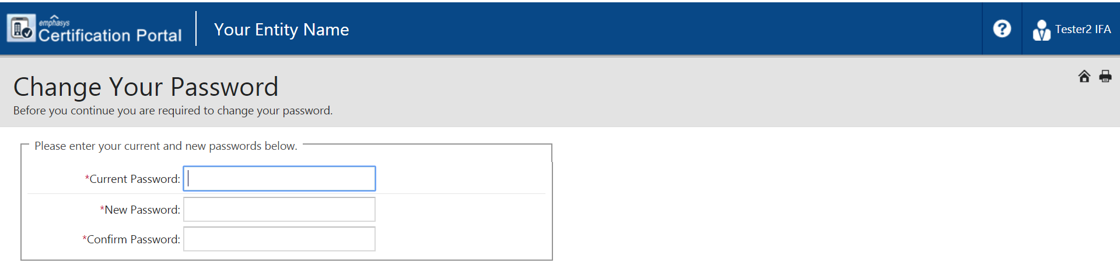
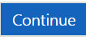

User Login screen

Forgot Username or Password
 Enter e-mail address and click 
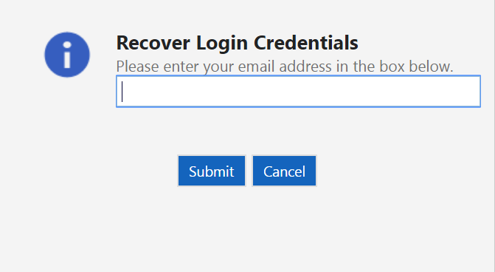

 Enter e-mail address and click

End Section 1
SECTION 2

ACCESSING PROJECTS

Once logged into CP, you will be on the Snapshot page and can access projects using different options.

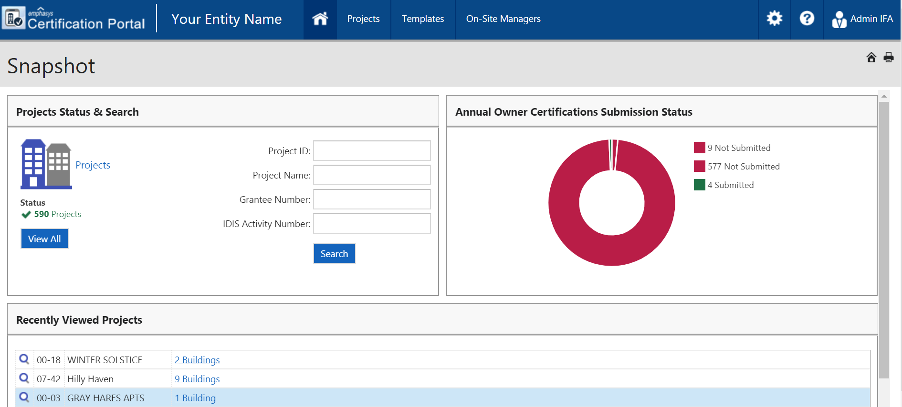

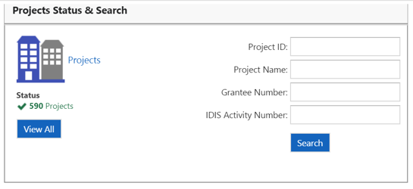
Option 1: Click on 
Option 2: Click on Projects 

Options 1 & 2 will take you to the screen below.
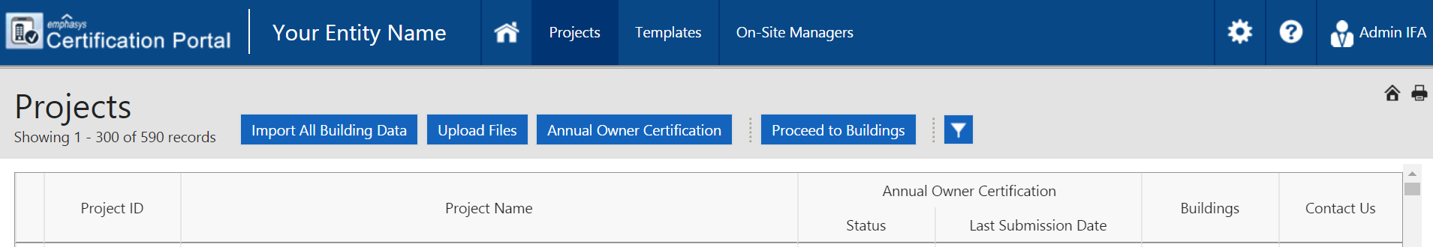
Option 3: Enter Project ID and/or Project Name. Project ID is for all programs, LIHTC, HOME or NHTF. Grantee Number and IDIS Activity Number is rarely used. Note: using this method requires the entries to be exact. (spelling, dashes, etc.)
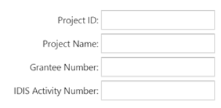

Click on  This option will take you to this screen.

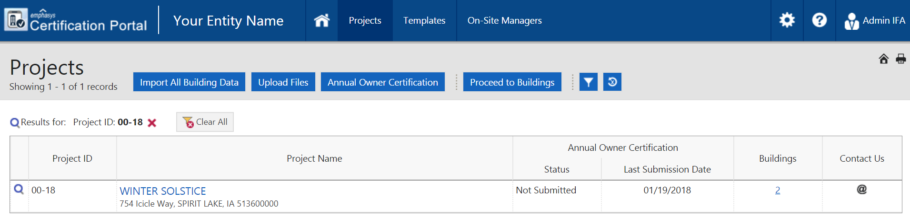

Option 4: If you have recently viewed projects, a list appears of those projects. 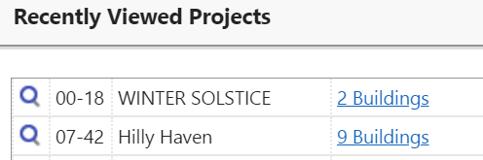

Click on  next to desired project. This option will take you to this screen.

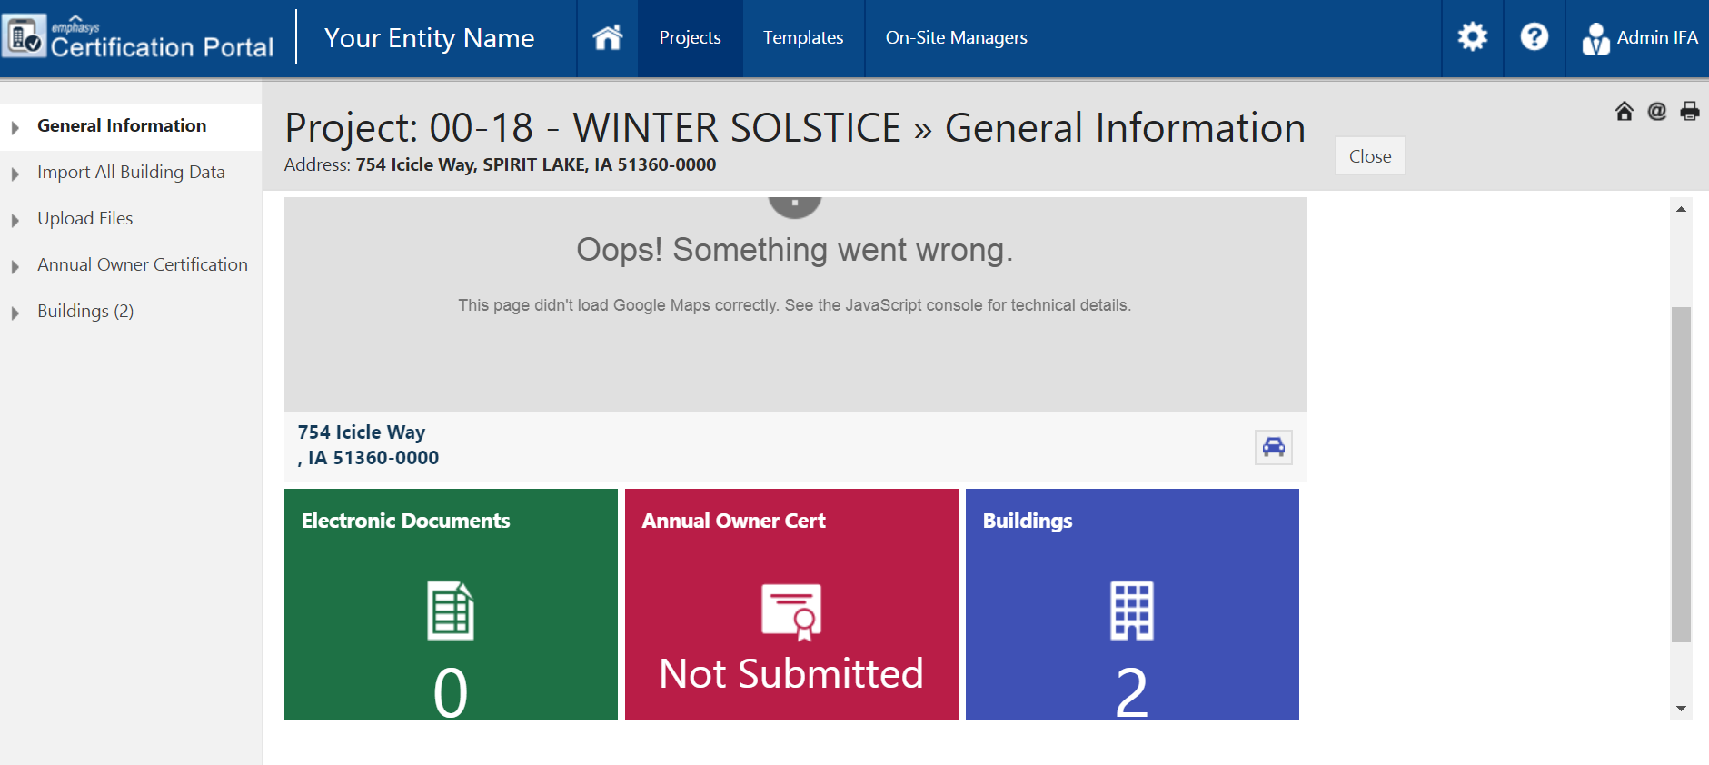

Option 5: Click on 

This will take you to your list of assigned projects.

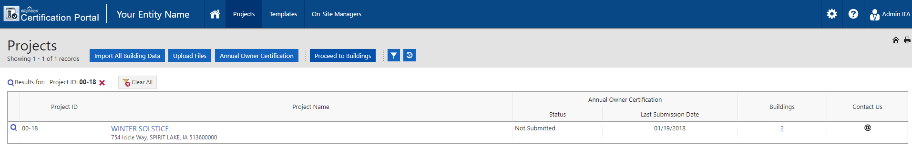

End Section 2

SECTION 3

MANUAL ENTRY
NEW MOVE IN

Select the project you will be working in. Click 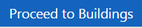

Select the building you are working in. Click on 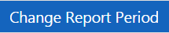
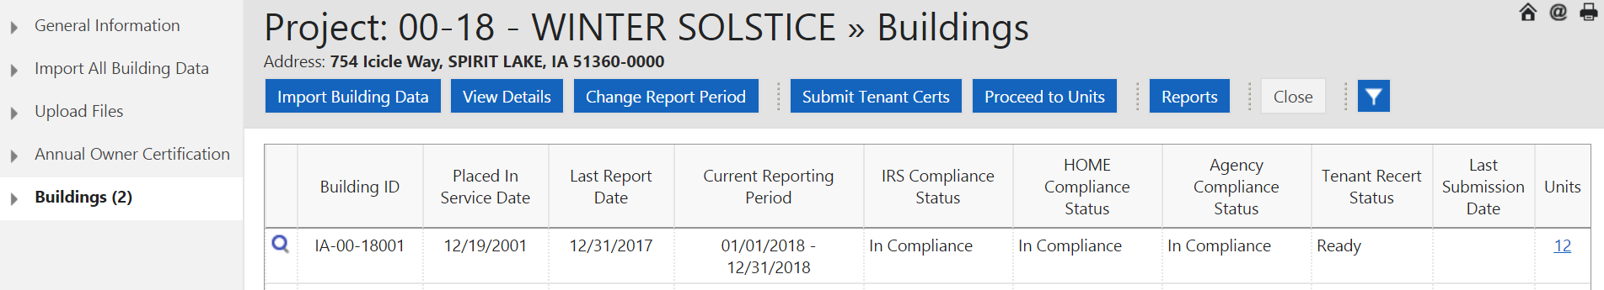

Enter the reporting year.
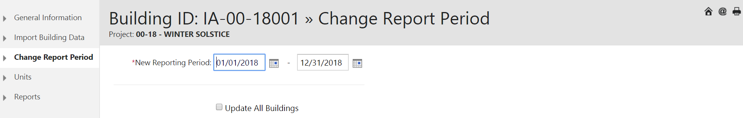

To update the reporting year for all buildings in the project, check the box and click 

Click on  in the menu on left side of screen.
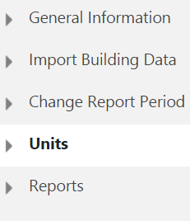

Select the unit you will be working in and click 
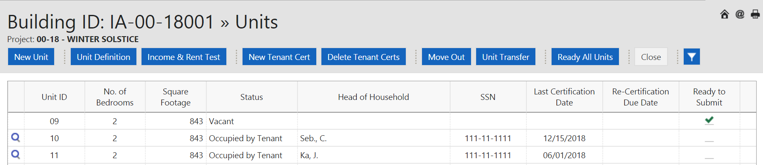

For General Head of Household information - at minimum fields noted with a * must be completed.
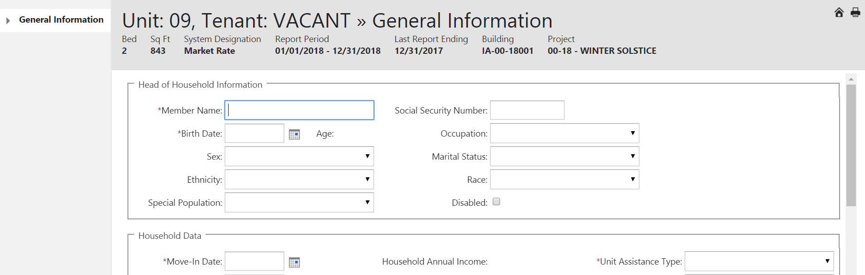
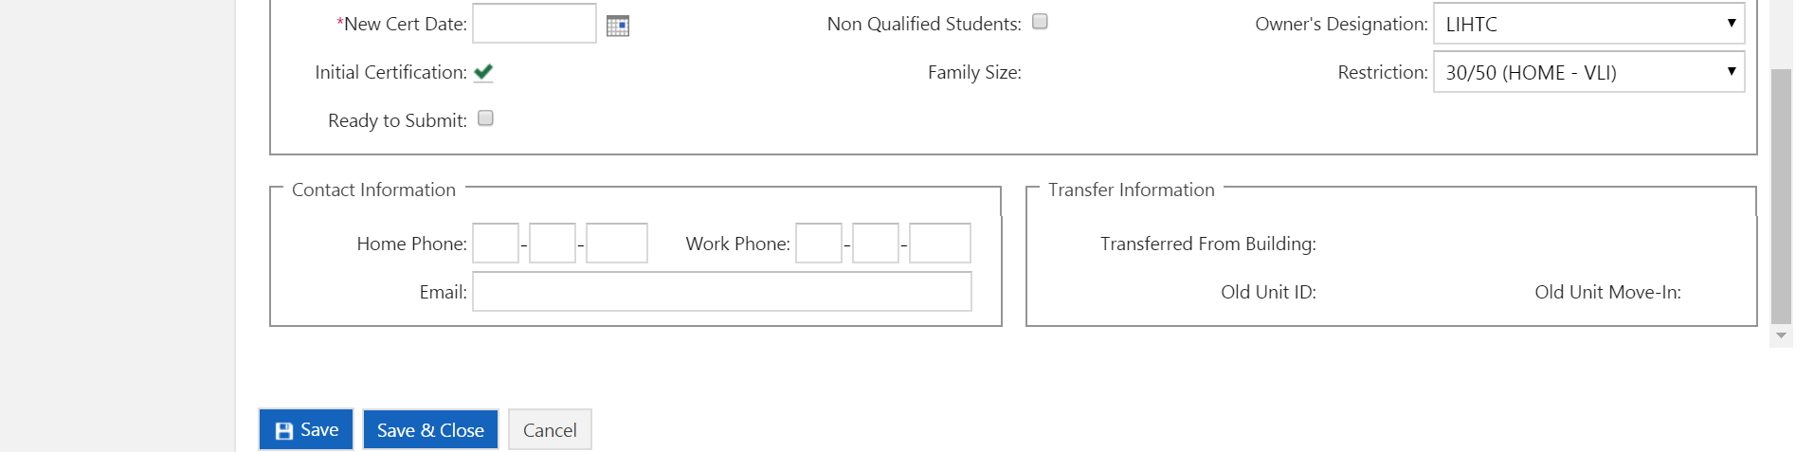

Enter Member (HOH) Name, Birth Date, Social Security Number (last four digits).
Ethnicity, Race, Disabled, Gender (sex), etc. are all optional and not required to be answered.
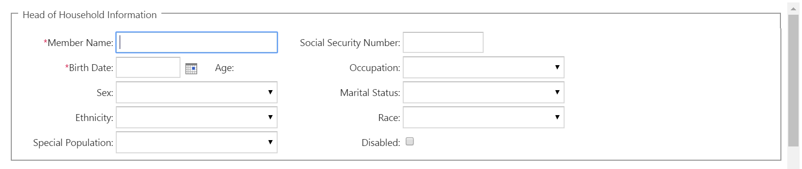

For additional Household Data -at minimum fields noted with a * must be completed.

Enter Move-in Date, New Cert Date, Unit Assistance Type, Owner’s Designation and Restriction. Check Non-Qualified Student, if applicable, and if household has students that do not meet any exceptions (HOME and/or LIHTC).
Initial Certification box will automatically check for Initial Certification. Family Size and Household Annual Income will auto-fill when family data is entered. Check box Ready to Submit when entry is complete.
Note: With a new move in, the Move-in Date and New Cert Date should be the same.
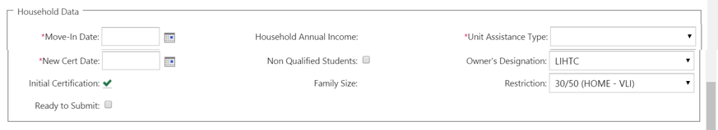

This information is optional in the system and not required by IFA.
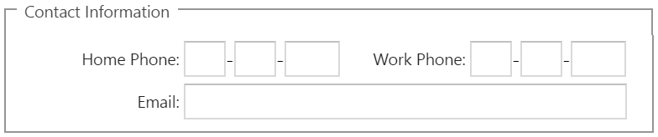

Click  when done with the page or  when ready to move to next unit.

When clicking a menu will open on left side of screen for entering additional household data.

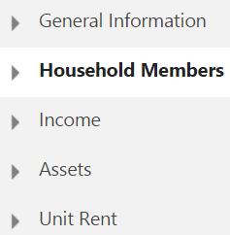

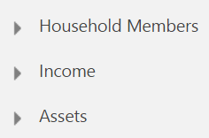
HOME ONLY projects are not required to enter detailed data, therefore these 3 links/sections may not be available.

If more than one household member, click  to add each additional (adults, minors, unborn child, etc.) member.

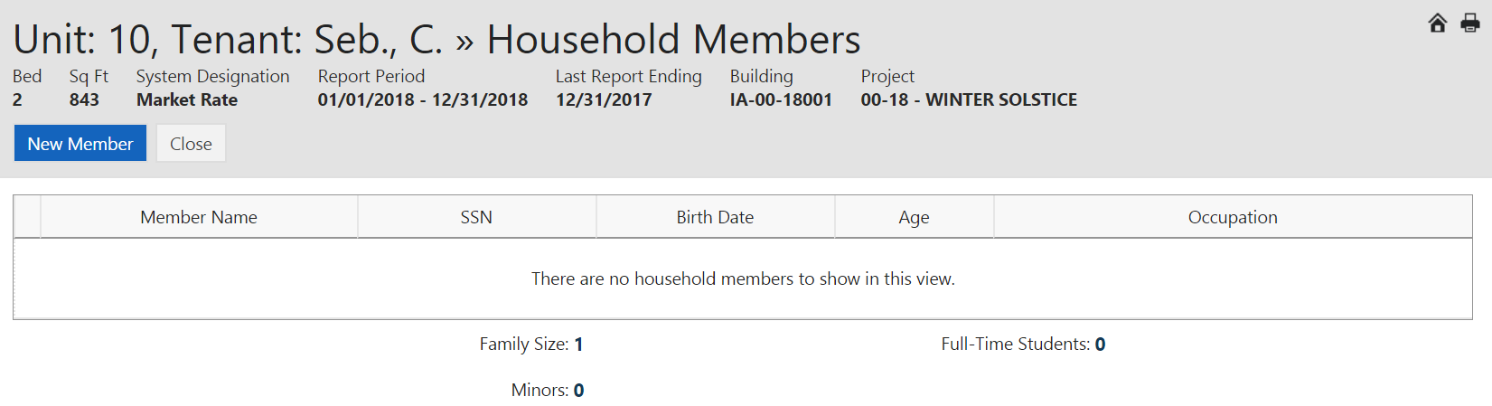

Click 
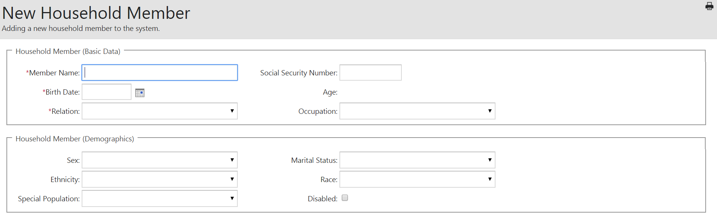


Enter Member Name, Birth Date, Relation and Social Security Number (last four digits).
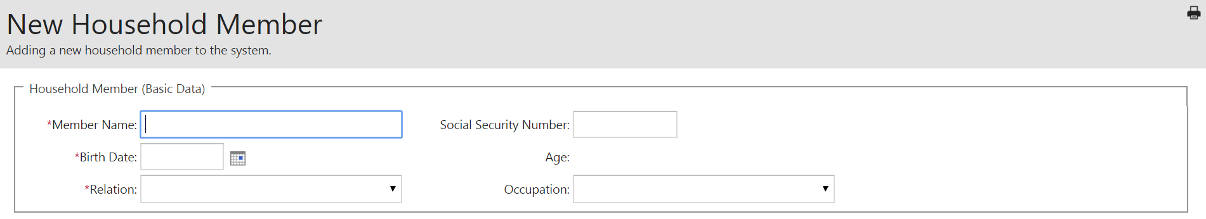

Ethnicity, Race, Disabled, Gender (sex), etc. are all optional and not required to be answered.

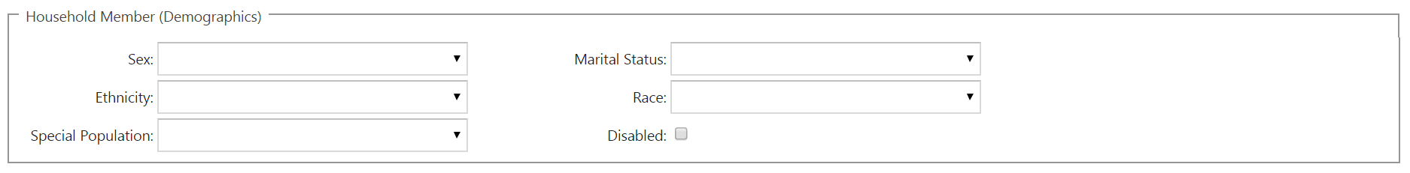
Click when done with the page,  to add additional members, or when ready to move to next unit.

To add all household incomes, click  on the menu on the left side of the screen.

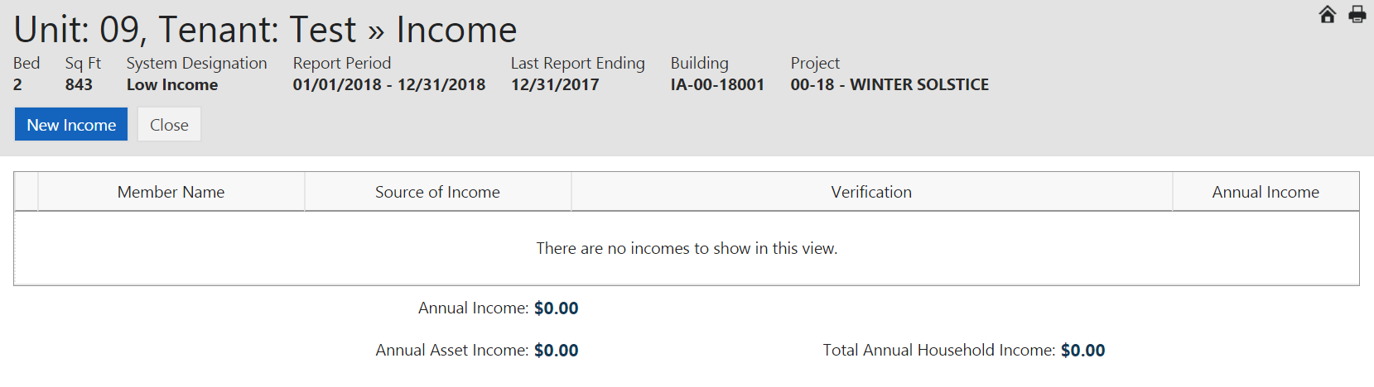

Click  to enter household income by Member Name. All boxes with down arrows have drop down selections. Income Source and Amount section must be completed although not asterisked *.
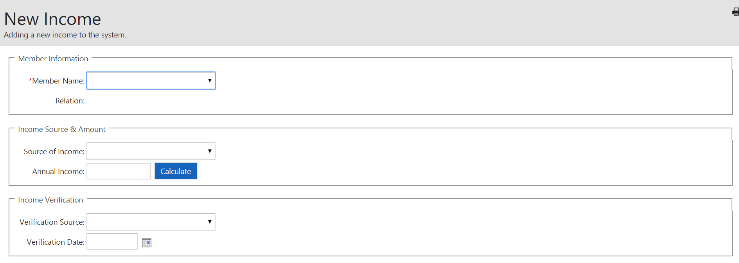



Member Information, click on down arrow to show a list of Member Names. Select name and Relationship.
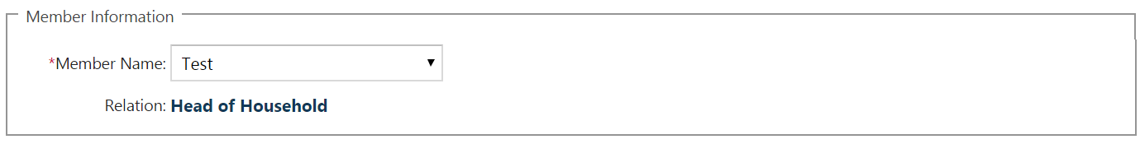

Income Source & Amount, click on down arrow to show Source of Income. Select type of income. Enter Annual Income for the selected member or use the Calculate button as explained below.
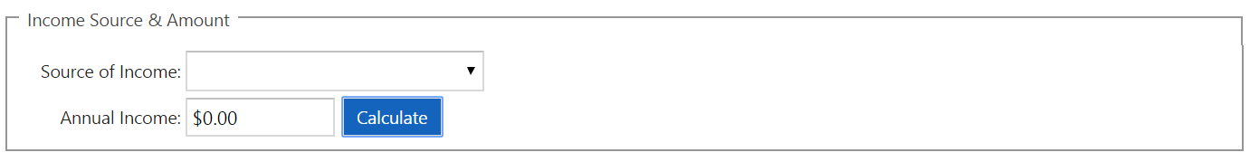
You can enter income listed on the TIC form in the tenant file or click on calculate  to have system calculate each earned income. Enter Pay Rate, Frequency, Hours per Year, and the system will calculate Annual Income. For each income to calculate, click . The calculated incomes will populate the Annual Income box to the Income Source & Amount.

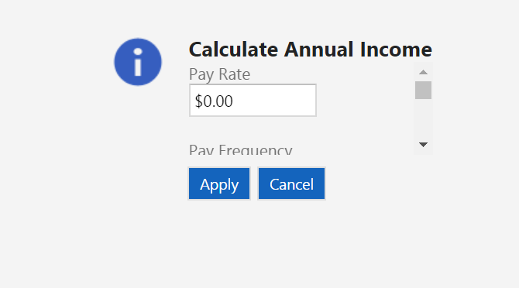

Income Verification, the Income Verification section is not required to be entered. However, if the property would like to use this feature, complete the Verification Source and Verification Date as applicable.
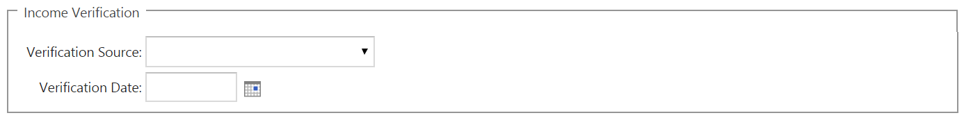

Once all incomes have been entered and saved, the main tenant screen will show a calculated Annual Income.
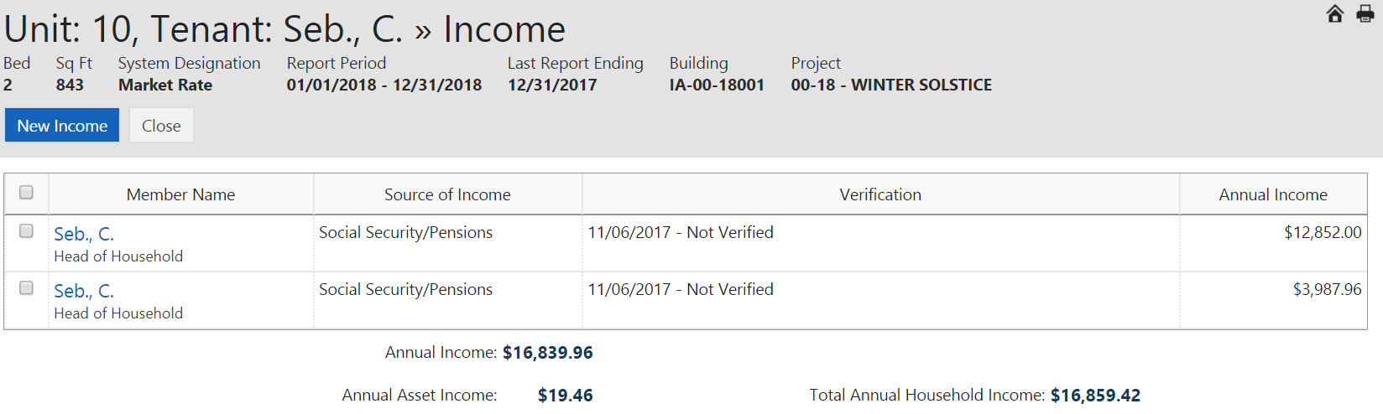

Click when done with the page or to add additional incomes or when ready to move to next unit.

To add all household Assets (if any), click  on the menu on the left side of the screen.

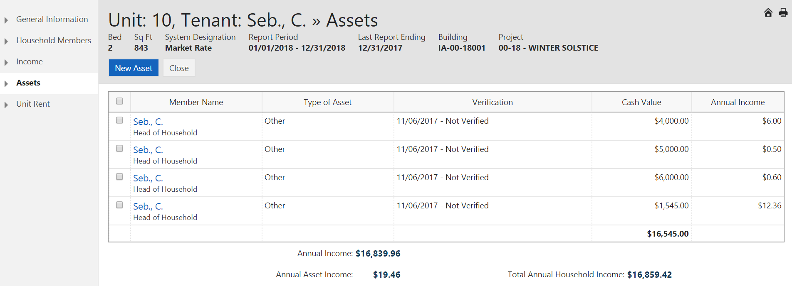

Click on  to enter household asset data by Member Name. Fields with down arrows have drop down selections. At minimum, fields noted with a * must be completed.

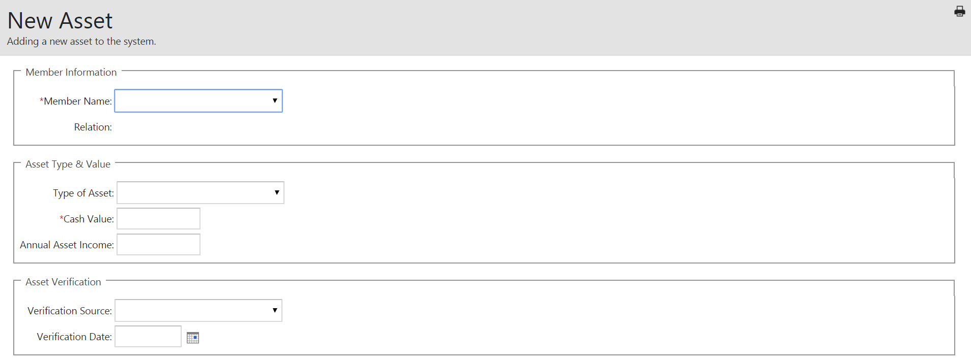
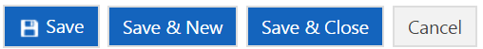
In Member Information, click on down arrow to show a list of Member Names. Select name and Relationship.
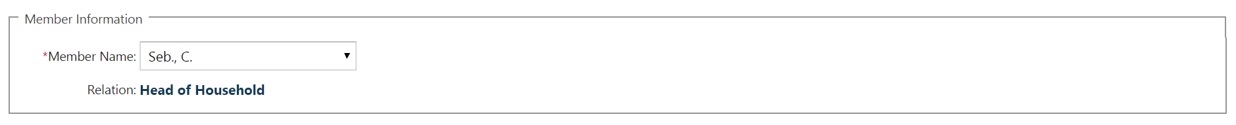

In Asset Type & Cash Value, click on down arrow to show Type of Asset and select type. Enter Cash Value and Annual Asset Income for the selected member.
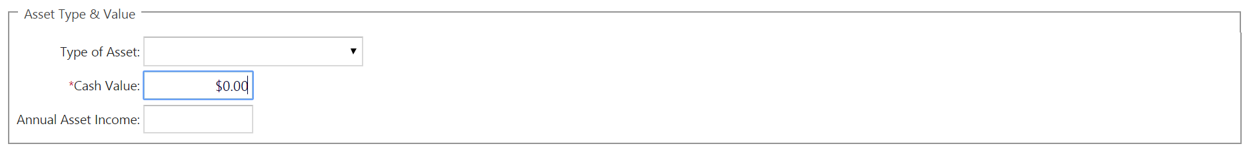

The Asset Verification section includes Verification Source and Verification Date. The Asset Verification section is not required to be entered. However, if the property would like to use this feature, complete the Verification Source and Verification Date as applicable.
Click when done with the page or to add additional Assets or when ready to move to next unit.

To enter rent data, click  on the menu on the left side of the screen.

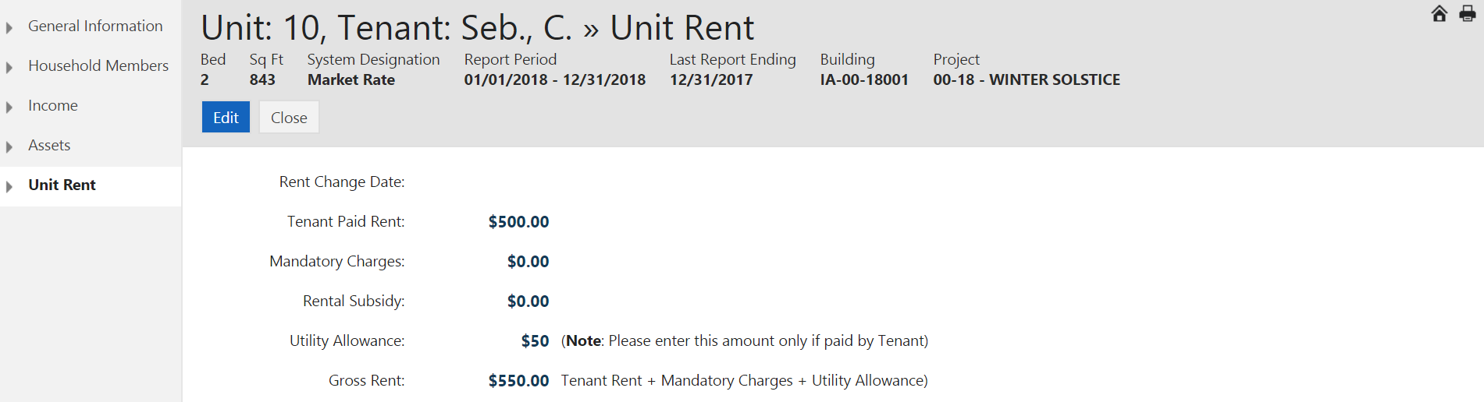

Click  to access Rent fields.
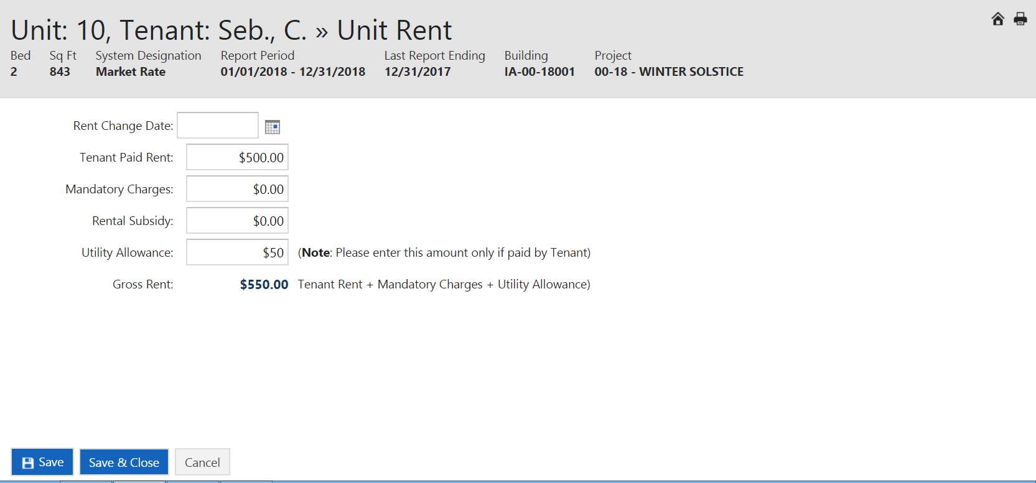
When all data has been entered in all screens in the unit, click 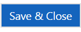 to return to Unit screen.

Rent Change Date:

**DO NOT** enter a Rent Change Date except in cases where a significant increase or decrease in rent has occurred at a time other than recertification that changes the tenant paid portion (TPP)., i.e. new subsidy added, subsidy removed, utility allowance changed, etc.

Tenant Paid Rent: This is the out of pocket amount the tenant pays (TPP) for rent.

Mandatory Charges: These are non-optional/mandatory fees that the tenant must pay as a condition of occupancy (garage rental, renter’s insurance, etc.).

Rental Subsidy: This is the amount of subsidy the tenant is receiving in rental assistance (Section 8 voucher or other government rental assistance).

Utility Allowance: This amount reflects what has been provided by the local PHA or an IFA-approved allowance.

Gross Rent: If Tax Credit only it will include Tenant Paid, Mandatory Charges, and Utility Allowance. If HOME/TC/NHTF or HOME or NHTF only it will include all fields.

End Section 3

SECTION 4

MANUAL ENTRY
RECERTIFICATION

For projects that are Mixed Use (have Market Rate units), full recertifications are required throughout the life of the project. For projects that are Mixed Income (have lower targeted Agency Covenant units), full recertifications are required on the lower targeted units throughout the life of the project. For HOME or NHTF, full recertifications are required every 6th year of the Affordability Period.

Select the project and 

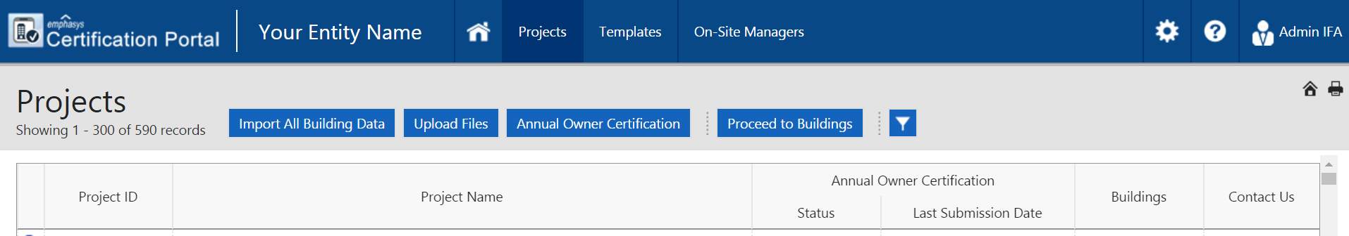

Select the building then click 

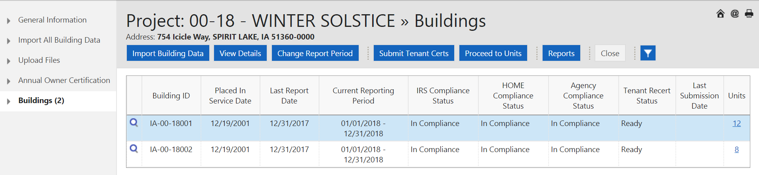

Select the unit then click 

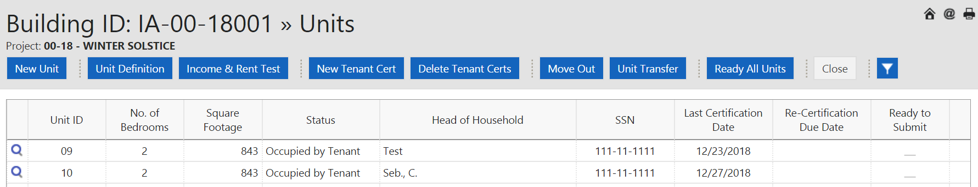

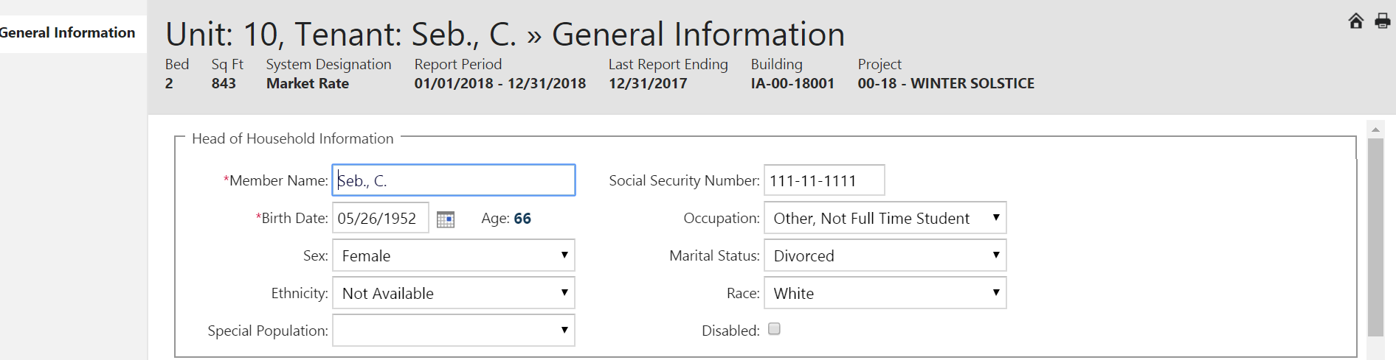
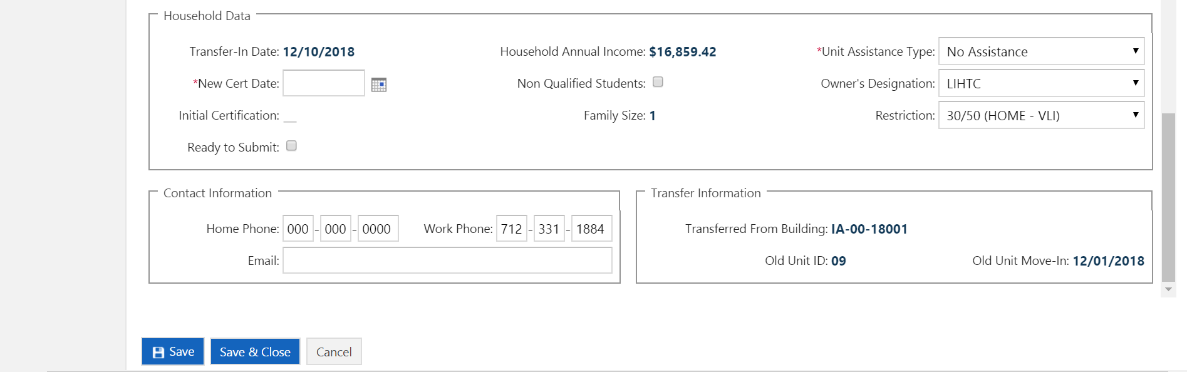

Enter New Cert Date  and click 

Click on member name then 

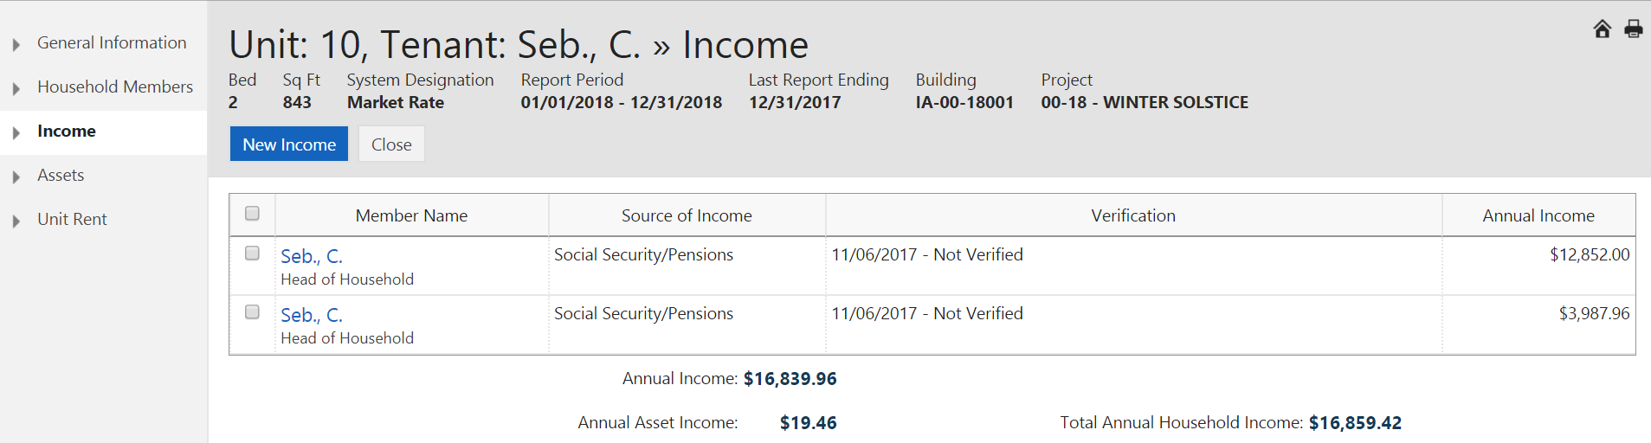

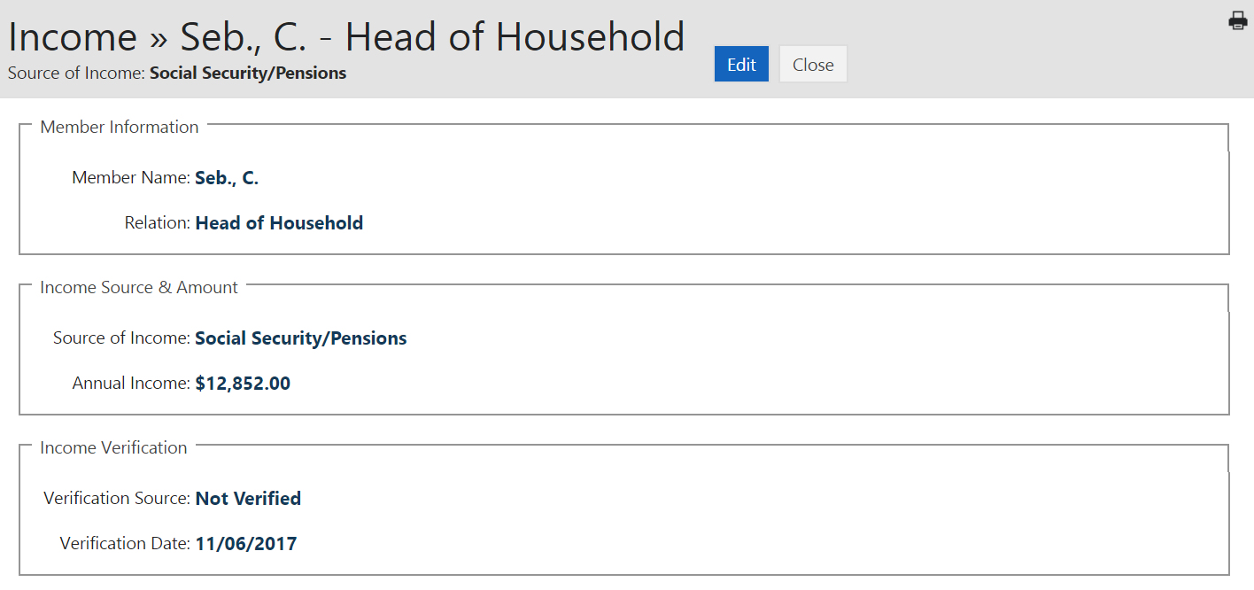

Click  and update the applicable fields.

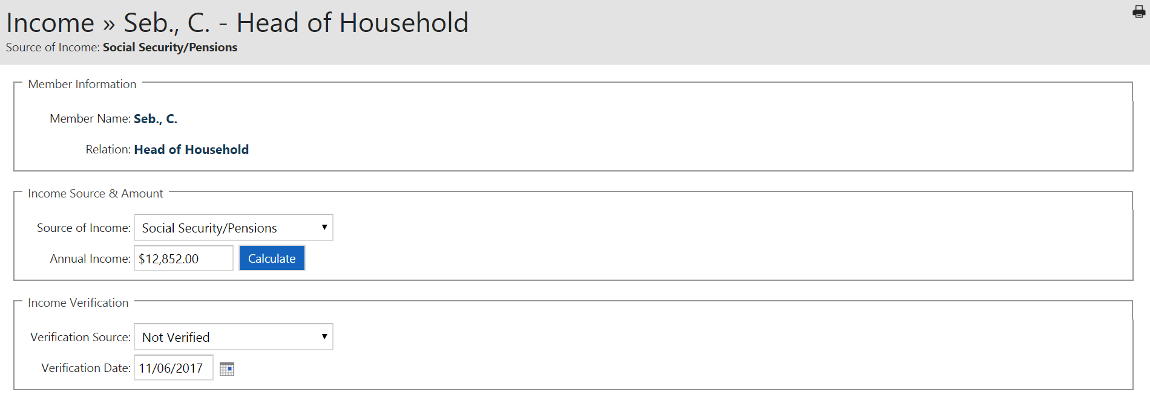
Click 

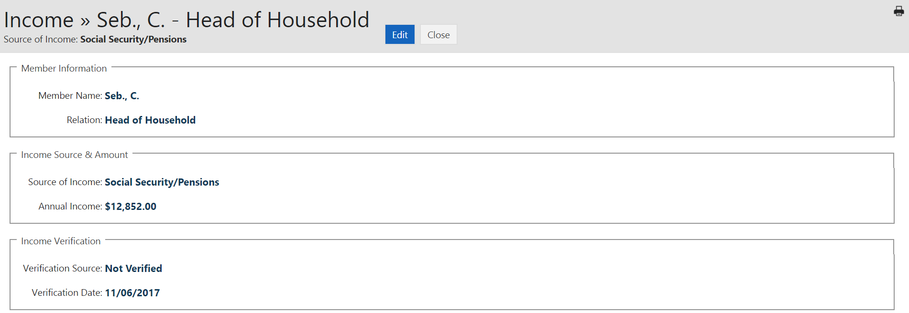


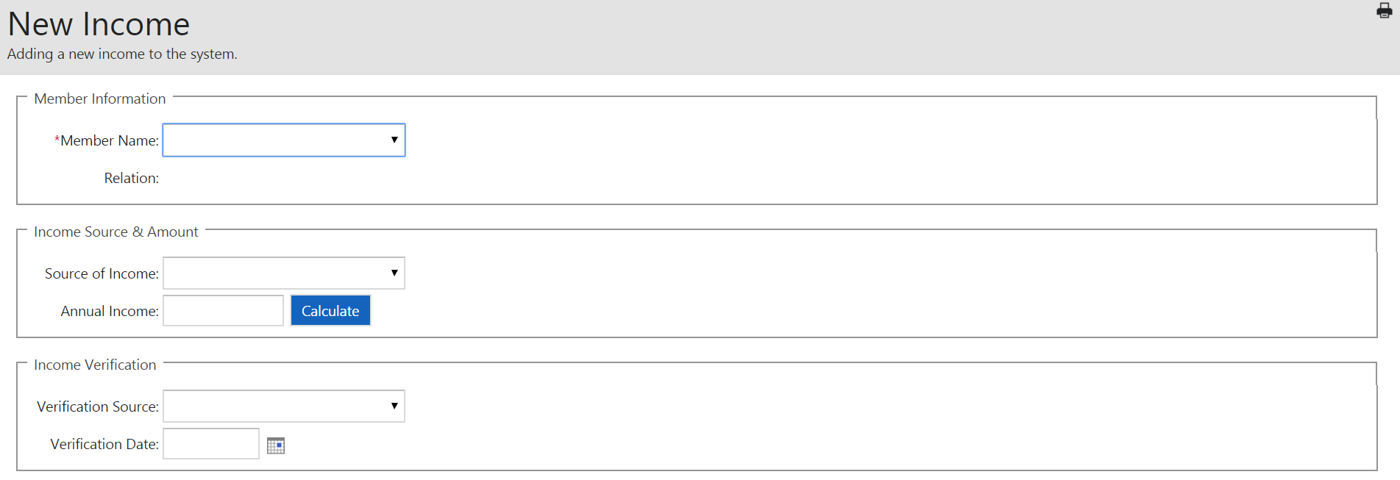


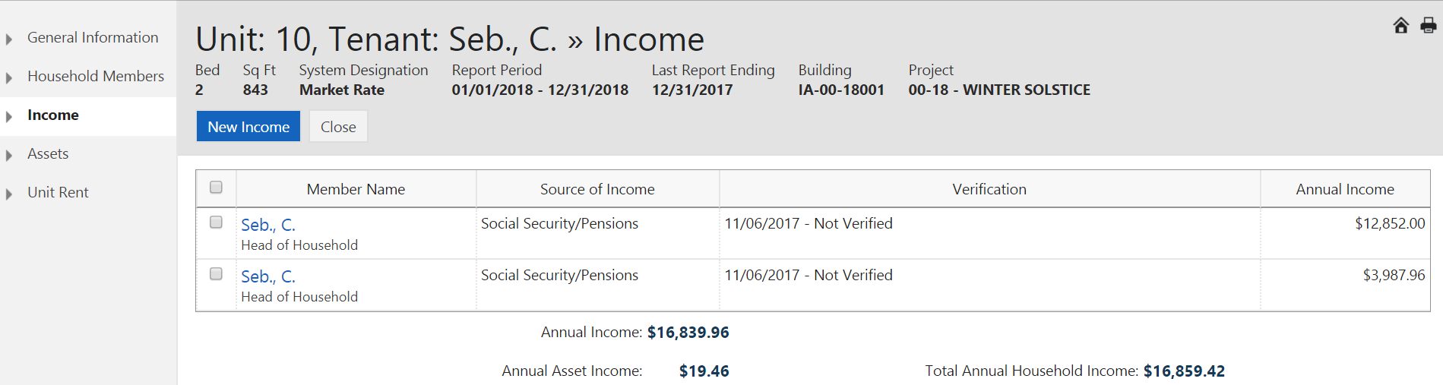

***Repeat income and asset edits and/or additional sources until complete.

 - IFA does not accept the CP system generated TIC form for file reviews. IFA has a required TIC form that can be found on the IFA website.

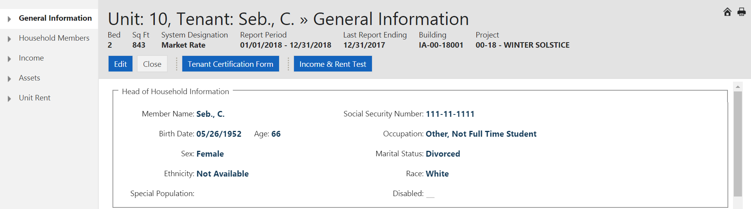



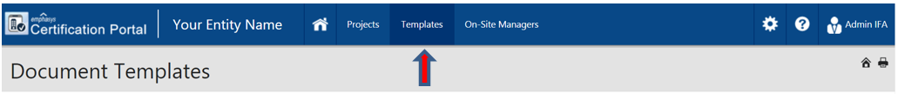

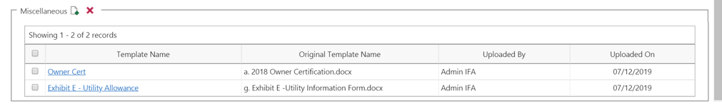

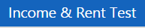

It is highly recommended you view the Income & Rent Test which will identify if the system determines Over Income and/or Over Rent based on Certification date and Effective Income and Rent dates.
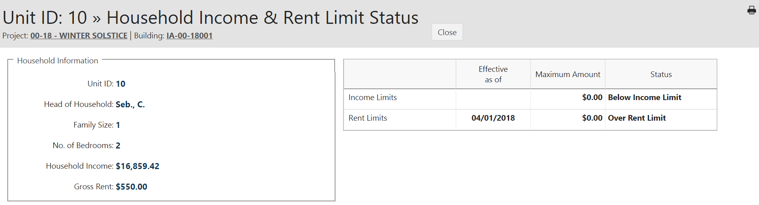

Click  if there have been any changes to the members. If a member (other than HOH) moved out during the year, click on the household member that you would like to remove. Once the tenant is selected, at the bottom of the page, 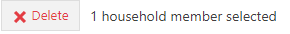will appear. Click on the delete button to remove the household member. If the household member that you would like to delete is tied to one or more incomes, the income for that person must be deleted first.

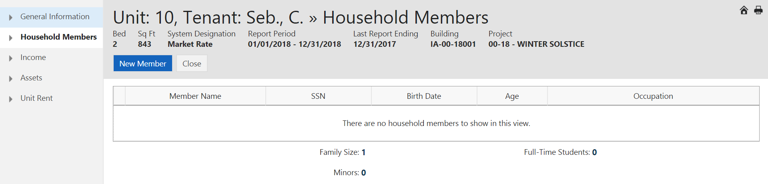

Upon reviewing all data entered in the system, if you identify an entry error, select 
NOTE: Move in dates can only be corrected by using Delete Tenant Cert.

Edit any field applicable and identified below and or 

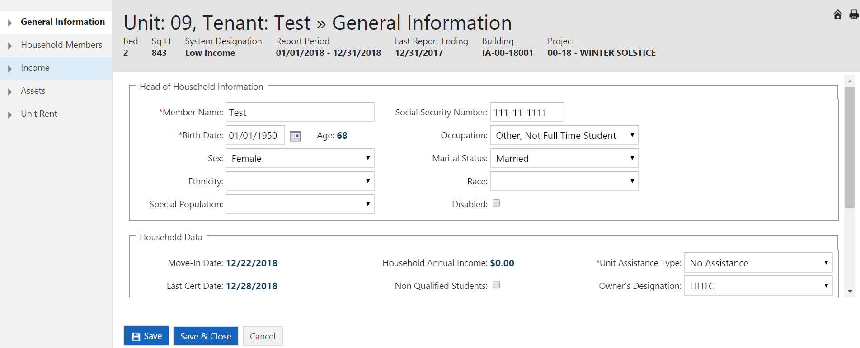

If a date of certification, move in, or transfer was entered incorrectly, click Delete Tenant Certs to remove the incorrect entry. Only the entry with can be deleted. When more than one entry has an delete must be completed starting from top entry.

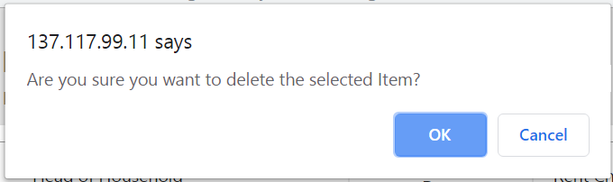

End Section 4
SECTION 5

MANUAL
UNIT TRANSFER

- Within Same Building (If only one building or 8609 8b election, when project has multiple buildings and owner elected to treat buildings as single buildings)

- Between Buildings (Multiple Building Project 8609 8b Election Only)

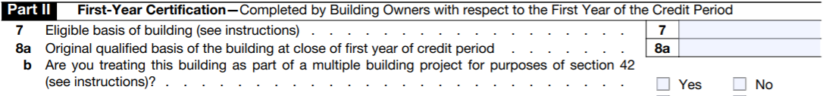

NOTE: Unit Transfers cannot occur on the same day. If the unit being transferred into, moved out the same day as the new transfer in, you will need to enter the day before as the move-out date.

TRANSFER WITHIN SAME BUILDING

Select the project and click 

Select the building and click 
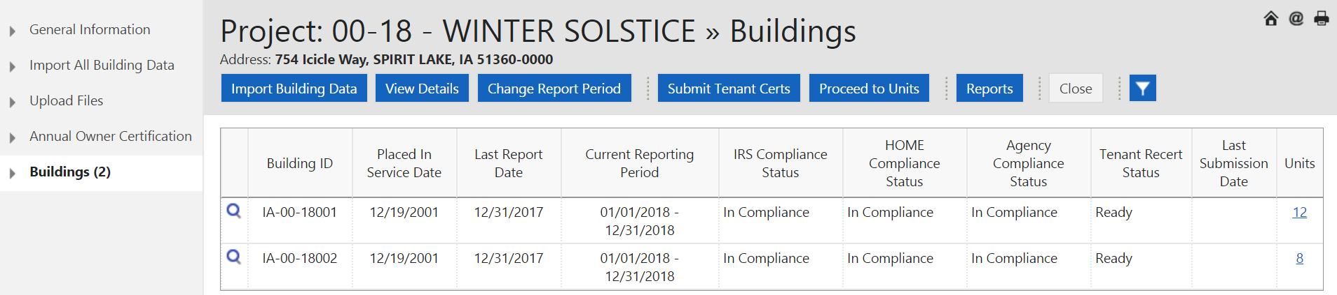

Select the unit that is transferring OUT and click 
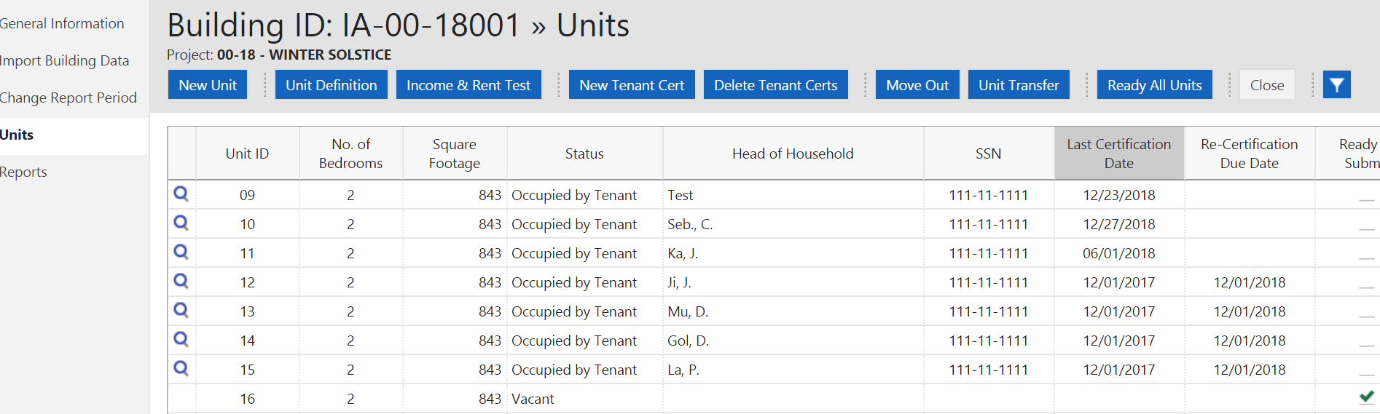
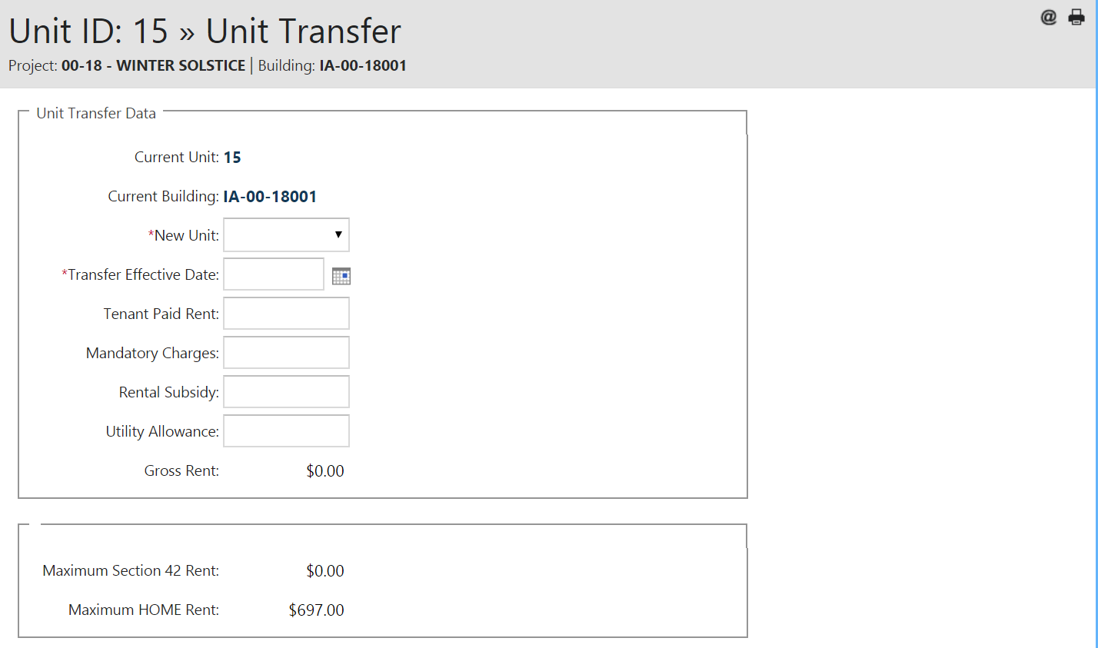
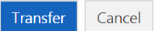
Click the down arrow in 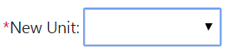 to show available units 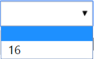 and select the unit to transfer to. Once selected, complete all fields.
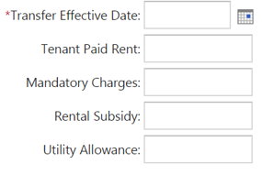

At the bottom of the page, click  to complete the action.

TRANSFER BETWEEN BUILDINGS– Based on 8609 8b election marked “Yes”.

Select the project and click on

Select the building and click

Select the unit that is transferring OUT and click

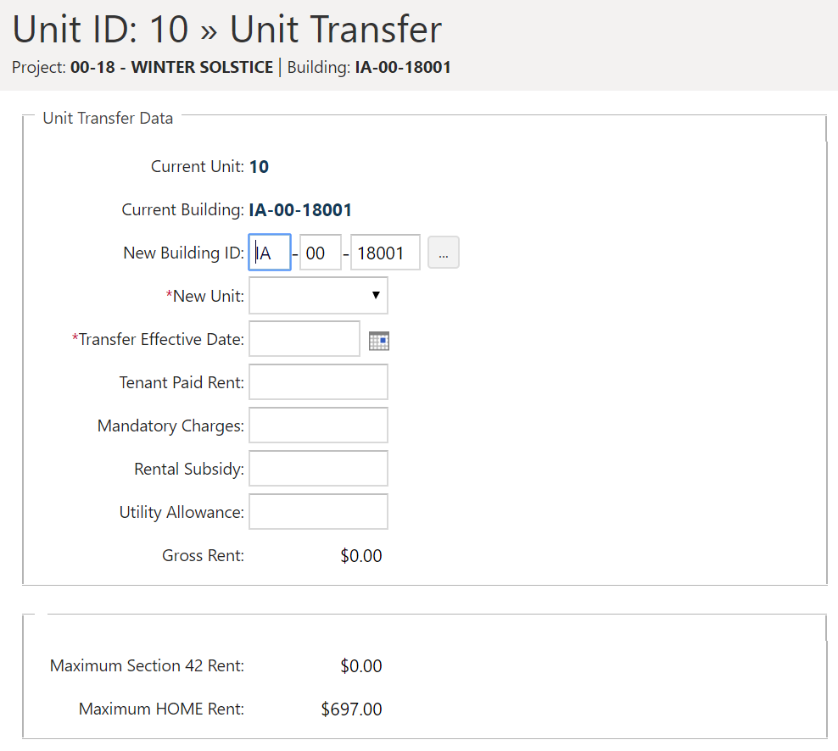

Click the  at the end of the Building ID to show available buildings and select the building the transfer-to is occurring.

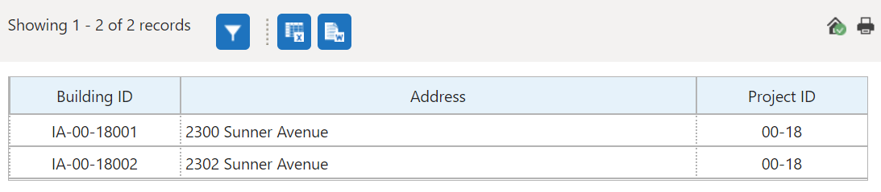

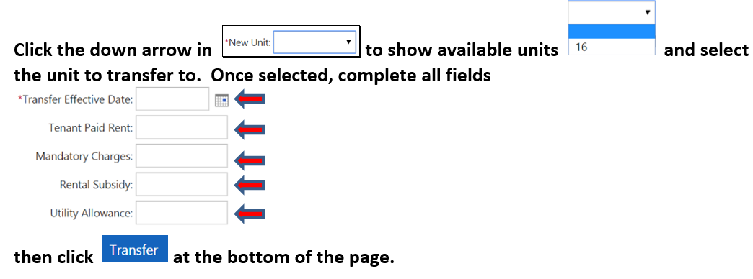

END SECTION 5
SECTION 6

MANUAL
MOVE OUT

Select the project and click

Select the building and click

Select the unit and click 

Enter  then click  at the bottom of the page.
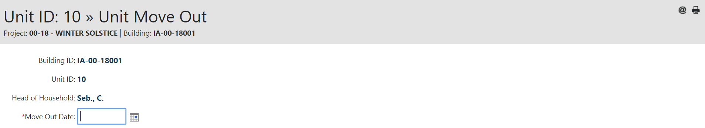
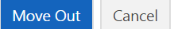
End Section 6
SECTION 7

3RD PARTY SOFTWARE
TENANT DATA IMPORT

- All Buildings – One File

- Single Buildings – Multiple Files (based on number of buildings in project)

UPLOADING ALL BUILDING XML FILE
If the 3rd party software (i.e., Yardi, RealPage, etc.) creates an XML file that includes all buildings in the project, highlight the project and click 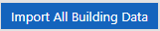

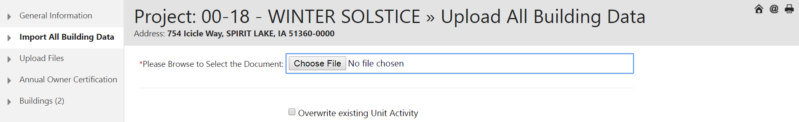

Click on Choose File

Select the XML file created by the 3rd party software (typically found on the C: drive).
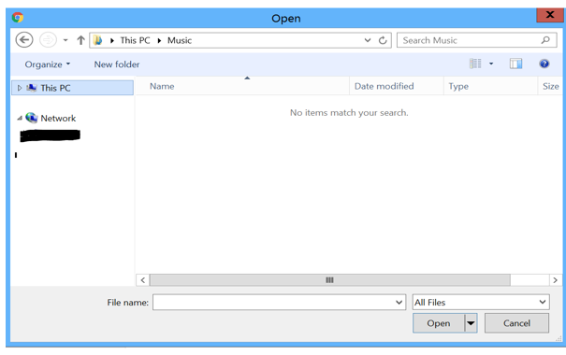

Select the XML file, click 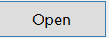 and click  to complete the process.
Documents can be imported multiple times for the same project as needed, due to errors. After the initial import, for any subsequent imports, you must check the box. 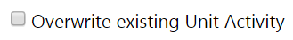

NOTE: If user is unable to locate file on the computer, search for XML l and it should show up.

IMPORTING SINGLE BUILDING(S) – Even if multiple buildings are in the project.

If the third-party vendor makes separate XML files for each building in the project, you will need to go to the Building Screen to import each of these files.

Highlight the project and click 

Select the building that matches the XML file and click 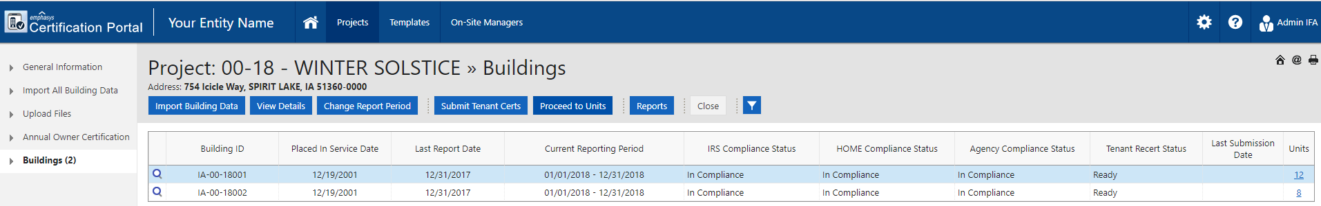

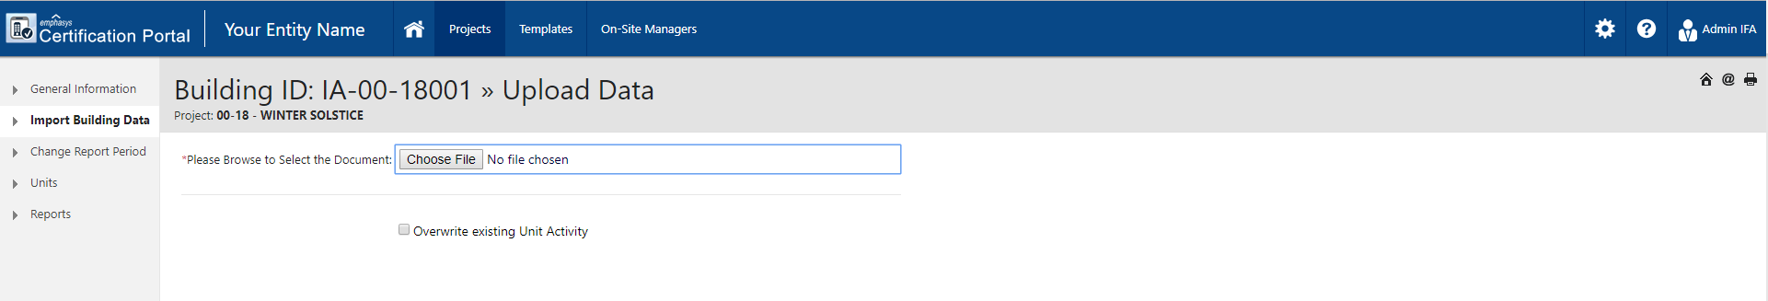
Select the XML file and click and then click at the bottom of the Upload screen to complete the process. This must be done for all buildings.

Continue this process until all buildings have been uploaded.

Go back to  and click  and click on  for each building.

Documents can be uploaded multiple times for the same project as needed, due to errors. For any subsequent uploads, check the box

If you upload incorrect BIN or Project XML file that does not belong to the selected project, this message will appear:

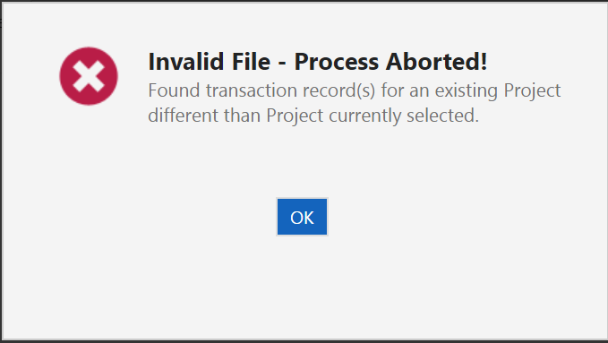

When an XML file has errors during import, the process will cancel and provide an Error Log (see below). If you receive an error message, provide a copy of the Error Log and XML file via email to the assigned IFA Compliance Officer for review, correction, and re-uploading.

Locate the correct XML file to upload or select 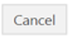and program will return to the building screen.

END SECTION 7

SECTION 8

Document Upload
(tenant files, inspection responses, annual reporting, etc.)

UPLOADING FILE DOCUMENTS

NOTE: This is different from the Upload Document above

Click on  to access Projects list. Select the project and click 

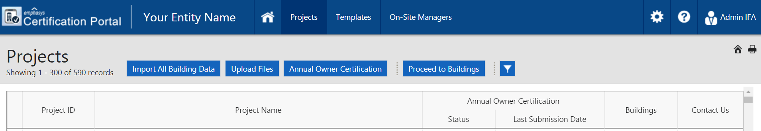

Scroll to the bottom 
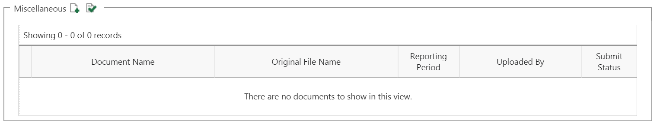
Click on  NEW icon to search for the file(s) for uploading:
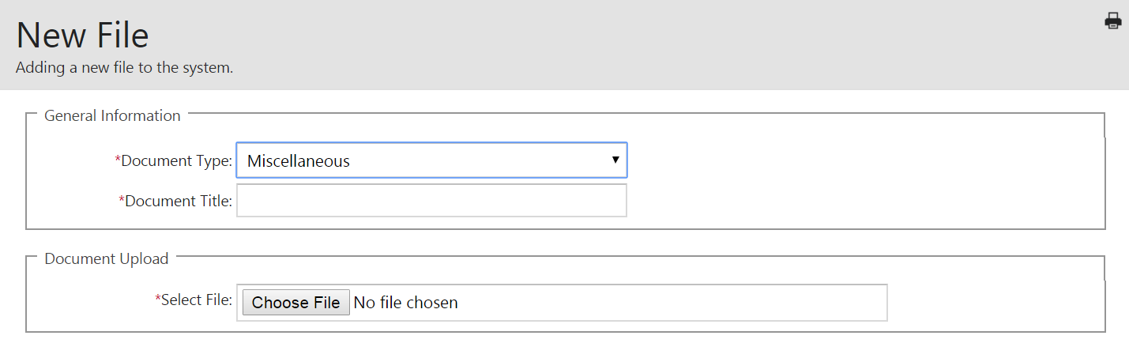

Document Type will always be Miscellaneous

Document Title should clearly identify upload example: Tenant file = Unit 100 Smith

Select File: It is best to zip the documents and upload as one file (not individual files for each unit).
NOTE: If you are unable to locate the file on the computer, search for .XML and it should show up.

Select how to proceed by using the buttons below. Buttons are at the bottom of the screen (screen must be maximized to access these).

If only uploading one set of files, click , if uploading more than one set of files, click 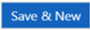

until all files have been uploaded and then .

End Section 8

SECTION 9
ANNUAL CERTIFICATION


IFA does not review or accept the CP system-generated Owner Certification documents. The system requires it to be submitted, to allow submission of the tenant data for each building(s). IFA has a required Owner Certification form with Exhibits which is provided annually via email and can be found on the IFA website.
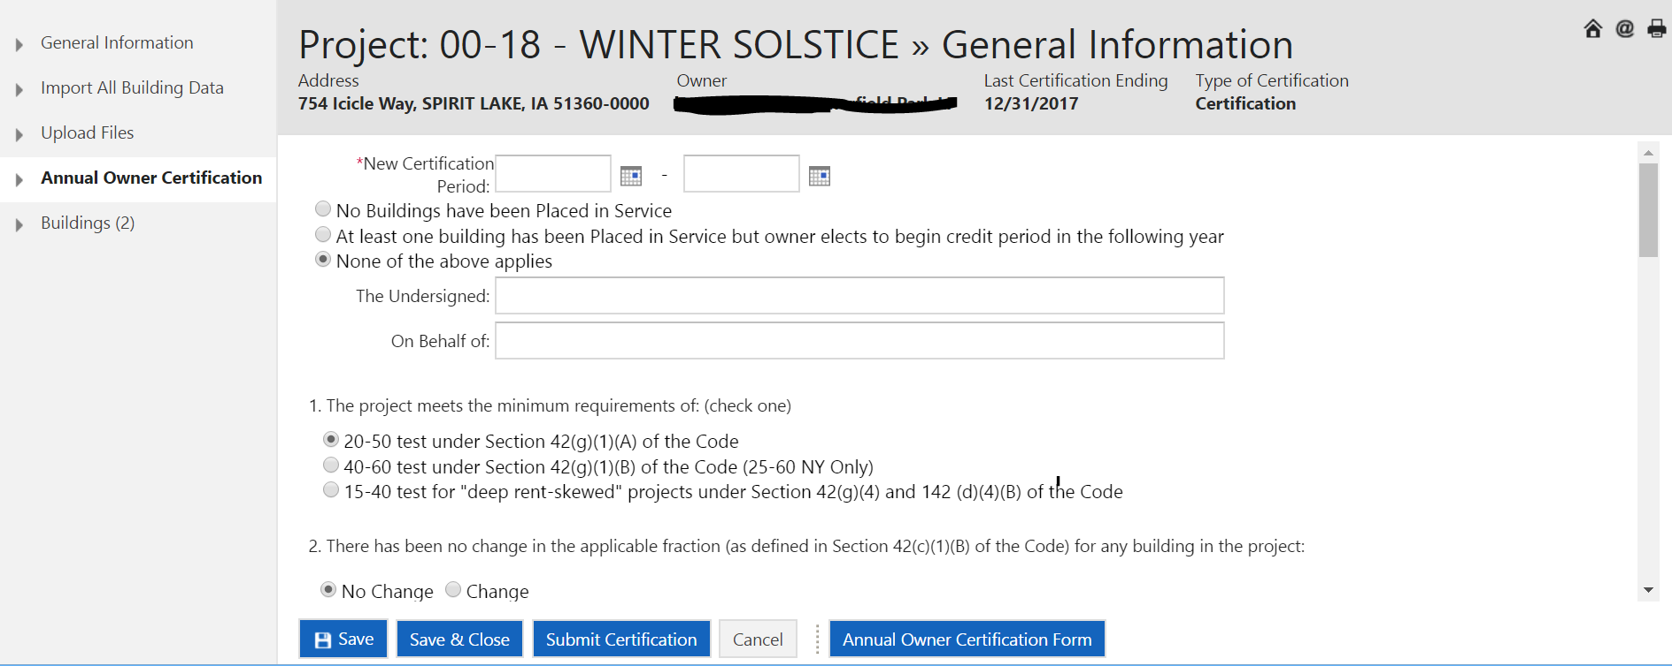

End Section 9
SECTION 10

REVIEWING DATA AND SUBMITTING TO IFA

IFA highly recommends the owner/management agent review all data entry prior to submitting.

REVIEWING UNIT DATA AND READYING UNITS FOR SUBMISSION.
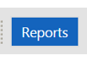
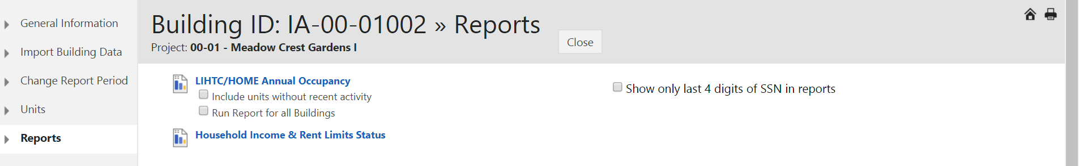

These reports can also be downloaded to Word, Excel, or PDF.
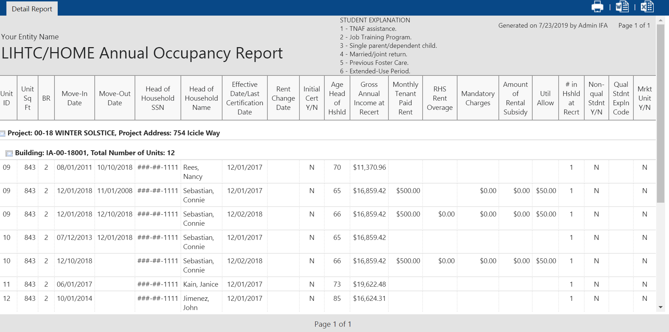


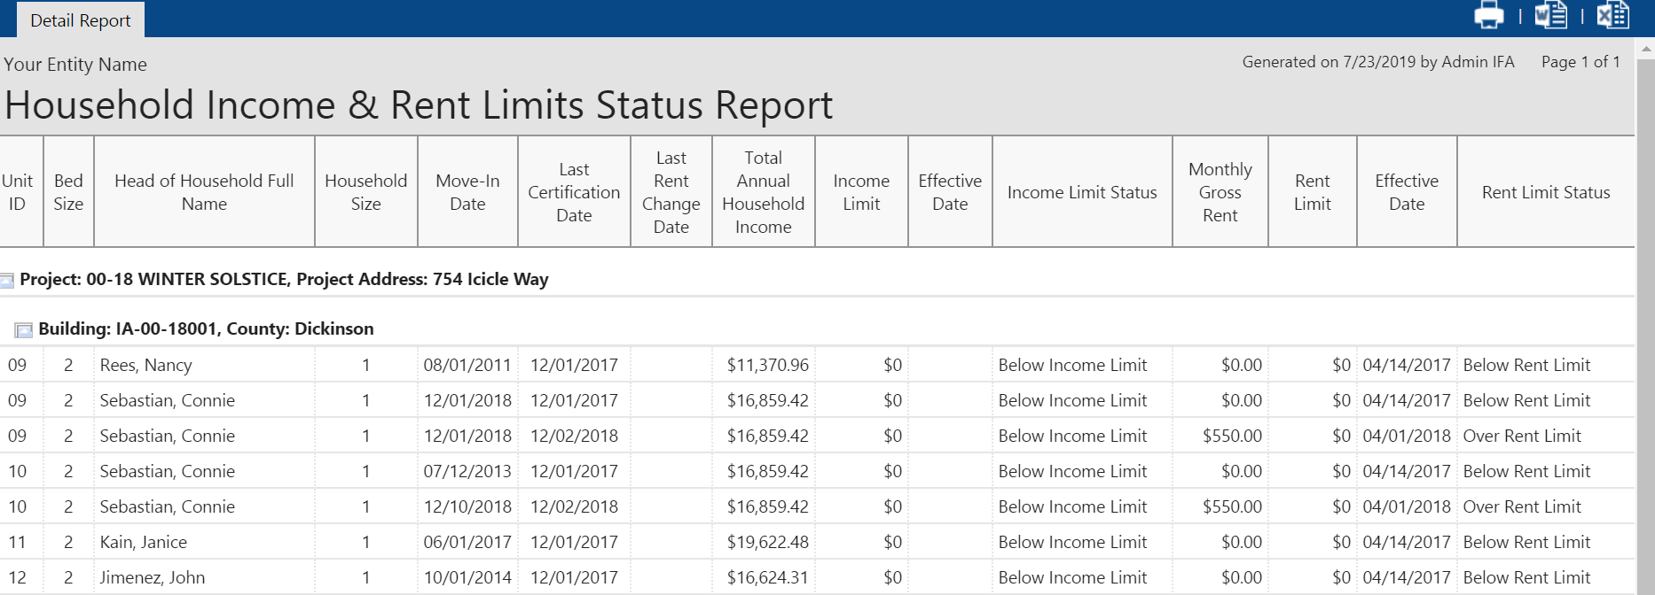

Once the data has been reviewed there are two ways to make a unit Ready to Submit.

At the BUILDING level screen:
Click 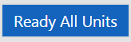 This allows the building to be submitted to the agency. When using 3rd party uploads, this is the preferred method to ready the units. Manual entries can also use this process by waiting until they have entered all unit data for the building(s).

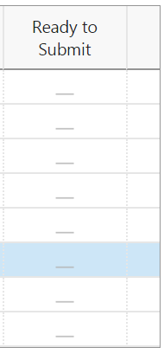
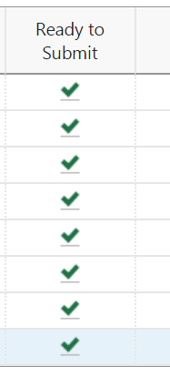

Or you can Ready the Unit each unit at the UNIT level screen. Select 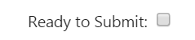 while in unit’s General Information screen. Click Save after checking box.

END SECTION 10

SECTION 11

MANAGEMENT CONTROLS
(SUPER USER)

UPPER MANAGEMENT CONTROLS (not typically on-site personnel)
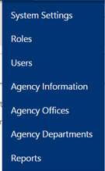

System Settings Security Tab will be used to set up user parameters. All other System Settings tabs are optional.
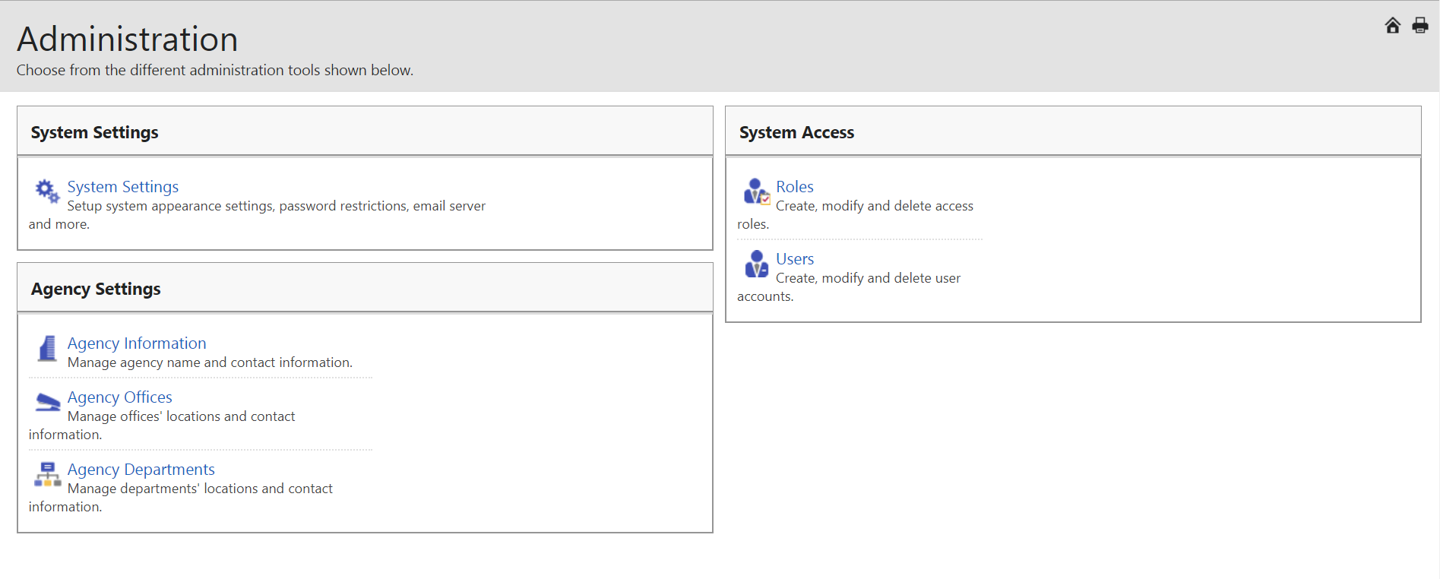


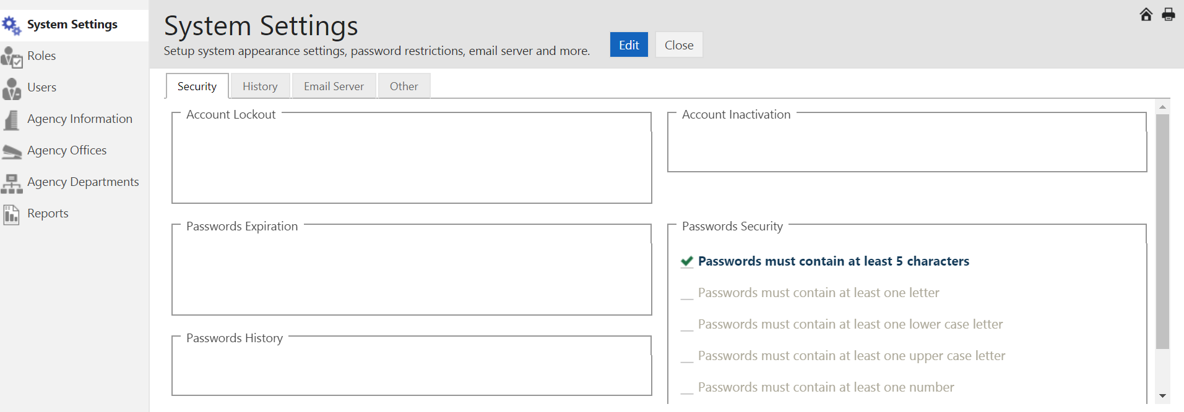
Click 

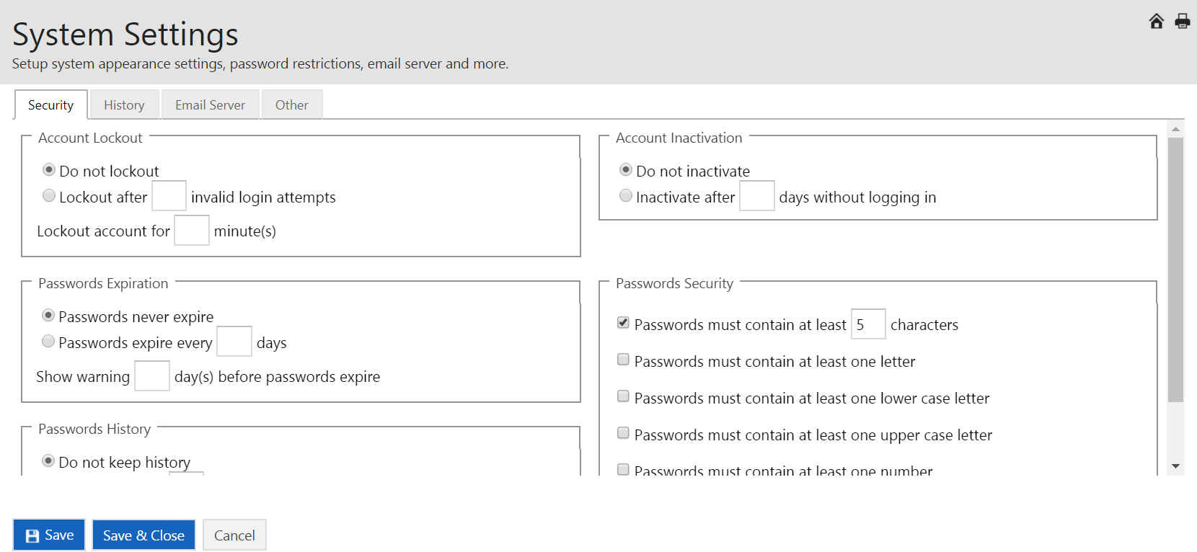

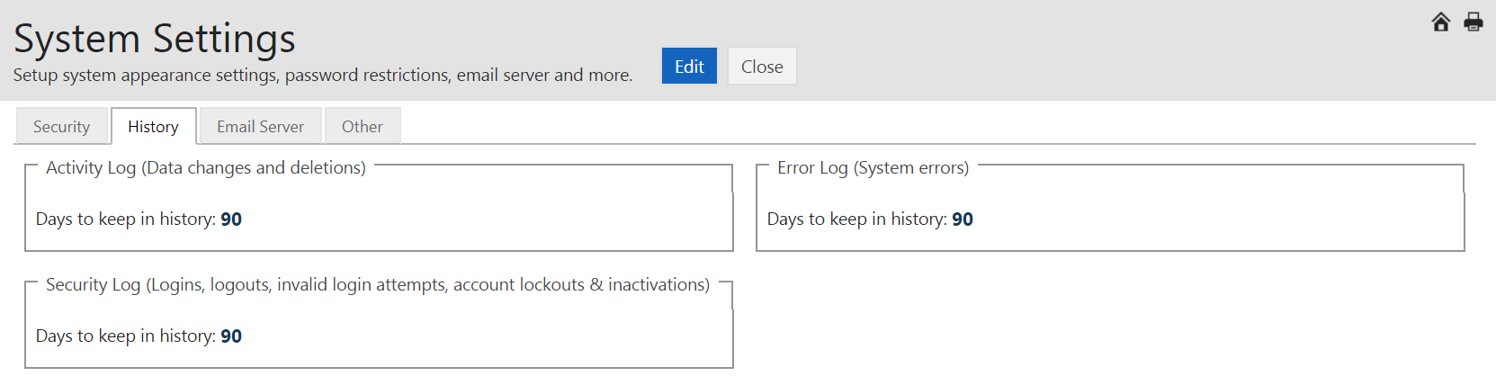

Click
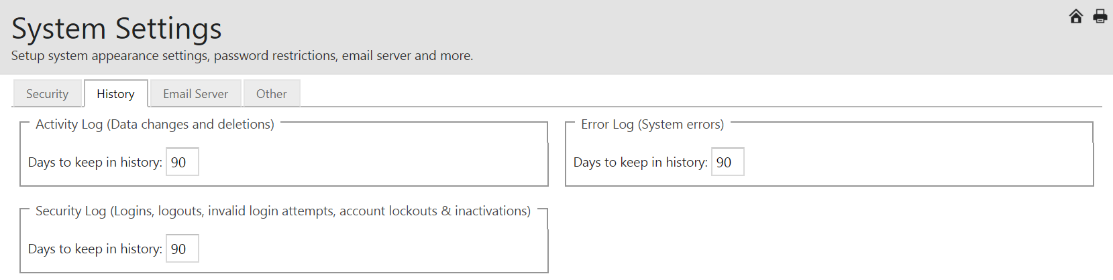
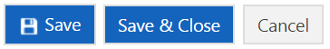

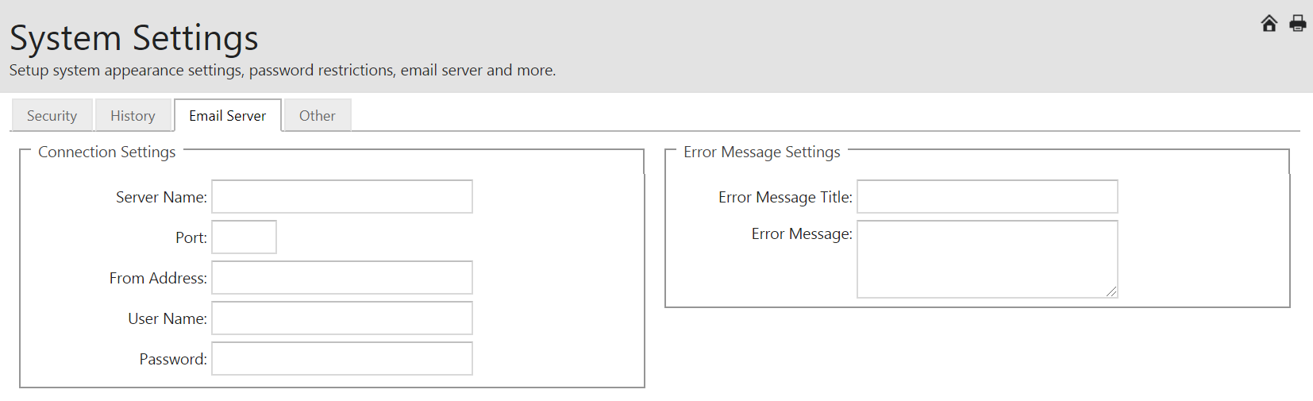
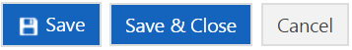

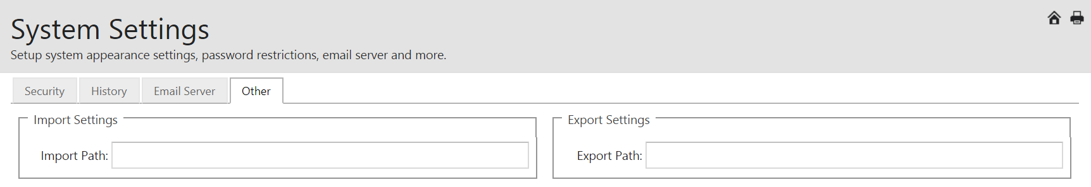


Setting up Roles to assign to individuals.
Roles only need to be set up one time and you can set up as many distinct roles as needed.
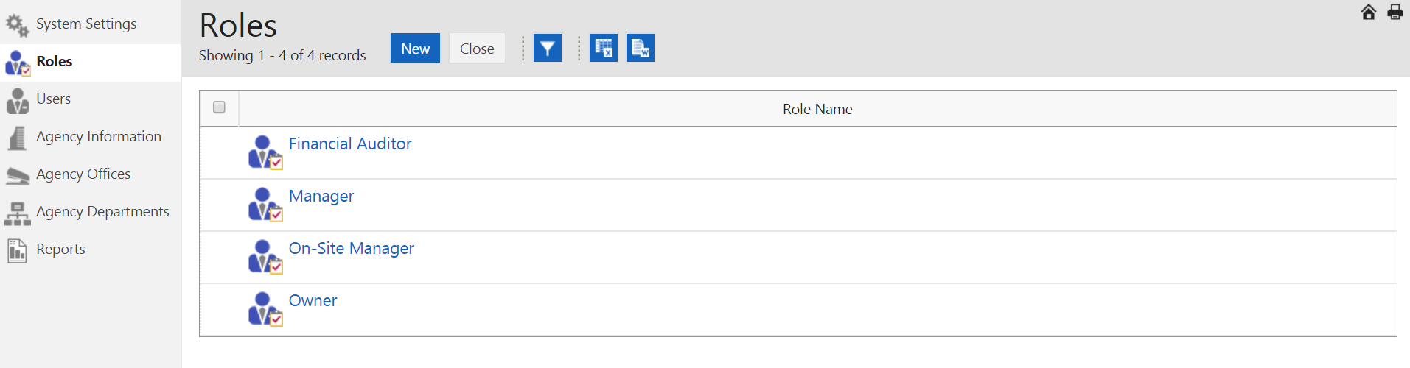
Click 
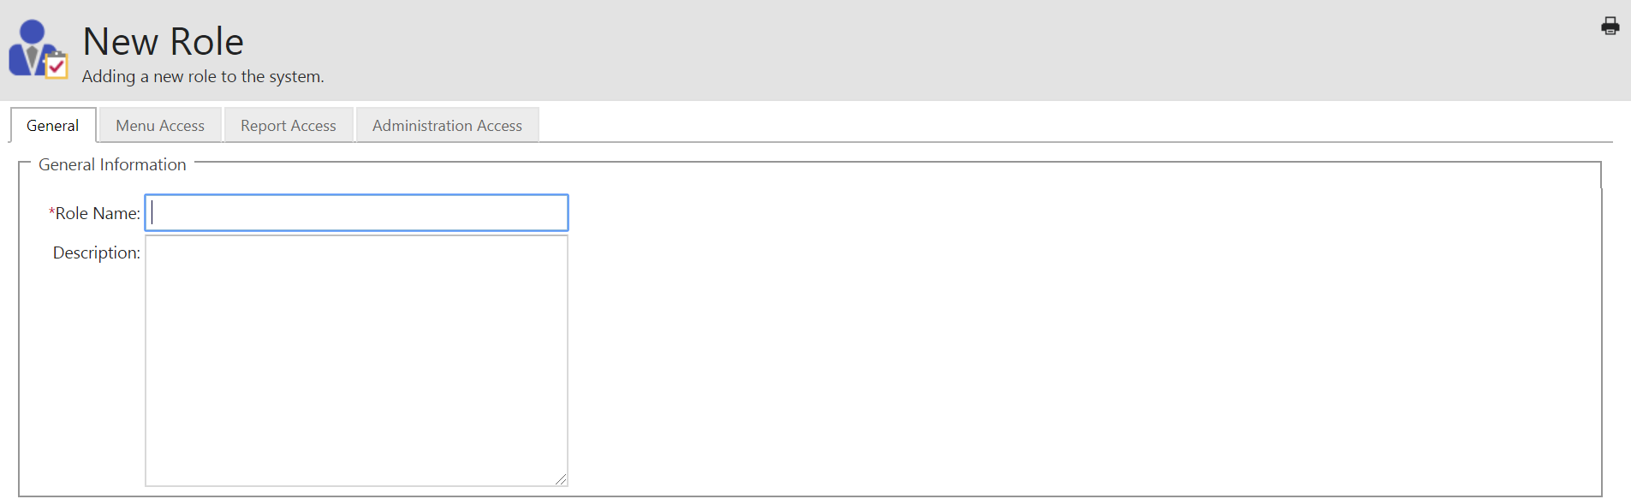
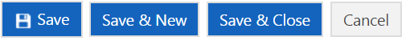

Assign the Role by clicking the boxes for specific menu access and various access levels within CP.
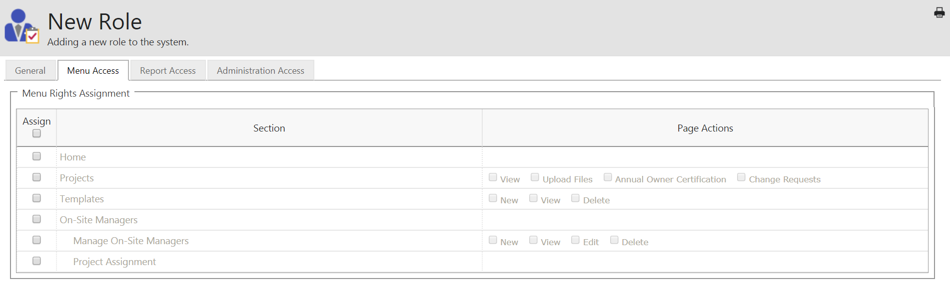

Select specific rights to the Role.
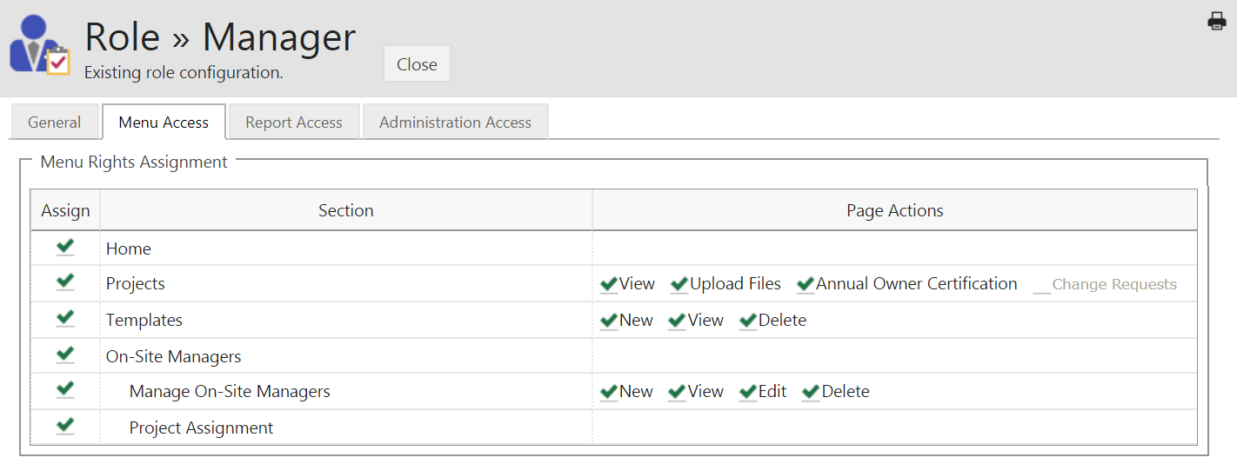

Set up Report Access for the Role.
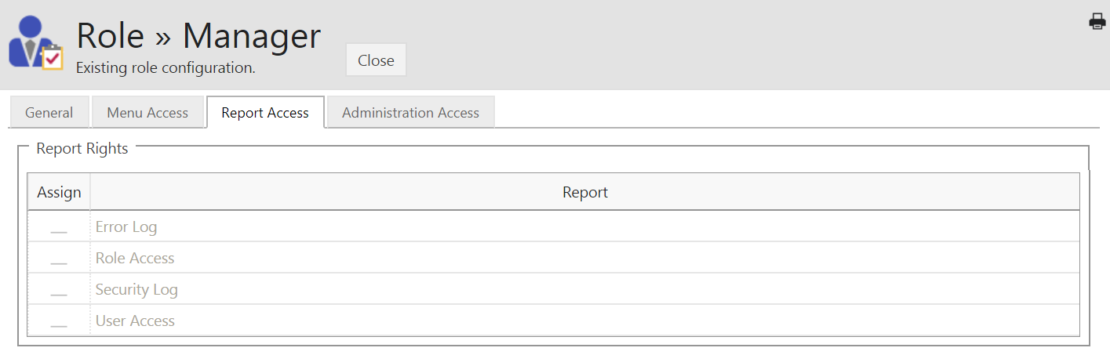
Assign rights by clicking each report.
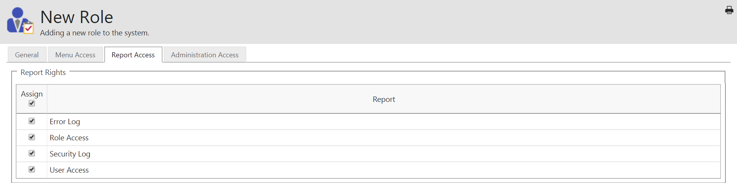

This Administrative Access tab is not available until a role is created. See 2nd example.
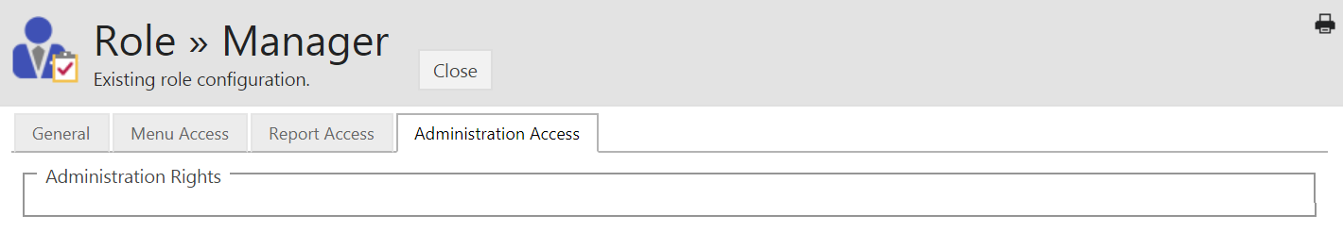

The box at the red arrow will not appear until a Role has been created.
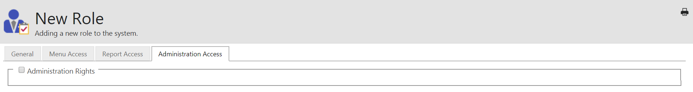

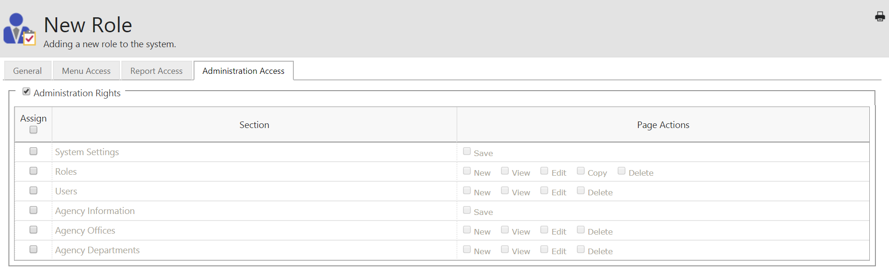


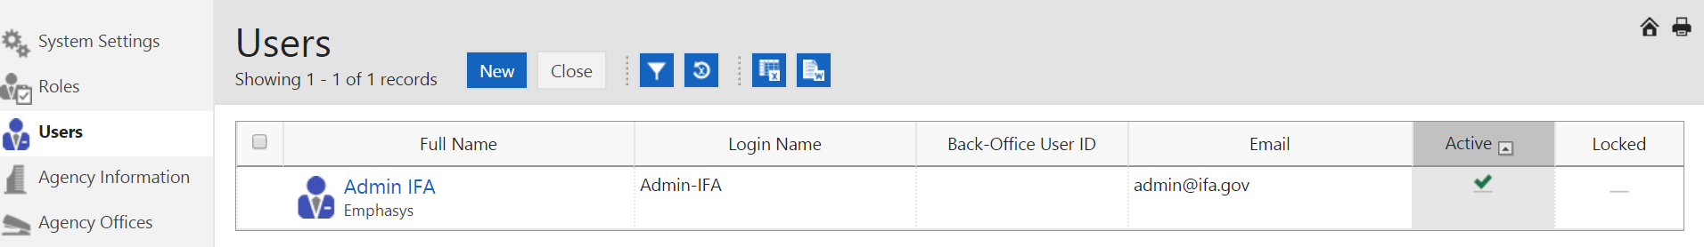


Enter all data for each tab, as applicable.
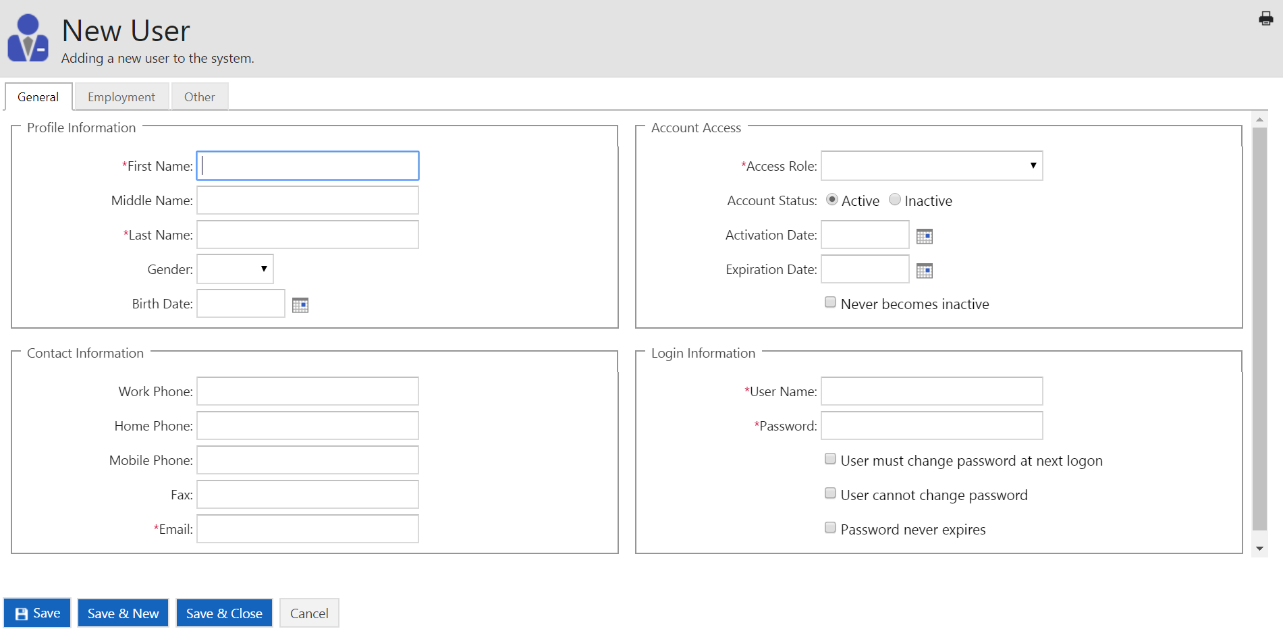

Click  to close screen,  to create additional users, or  to go back to main screen.
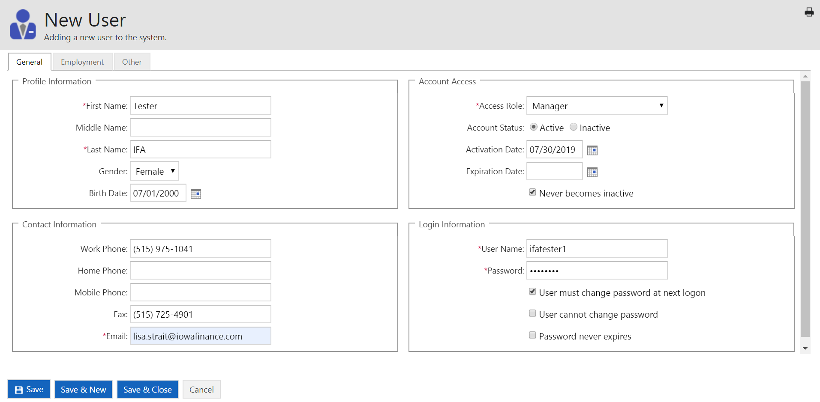

Adding Users


First, the Super User will add the On-Site Manager:

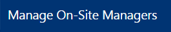
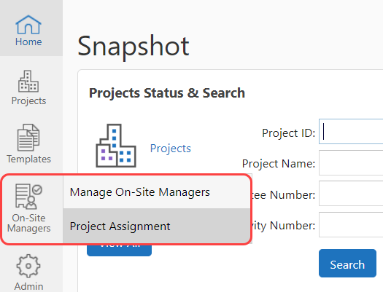

Click 

NOTE: The username and password fields require at least 6 characters and are case sensitive.

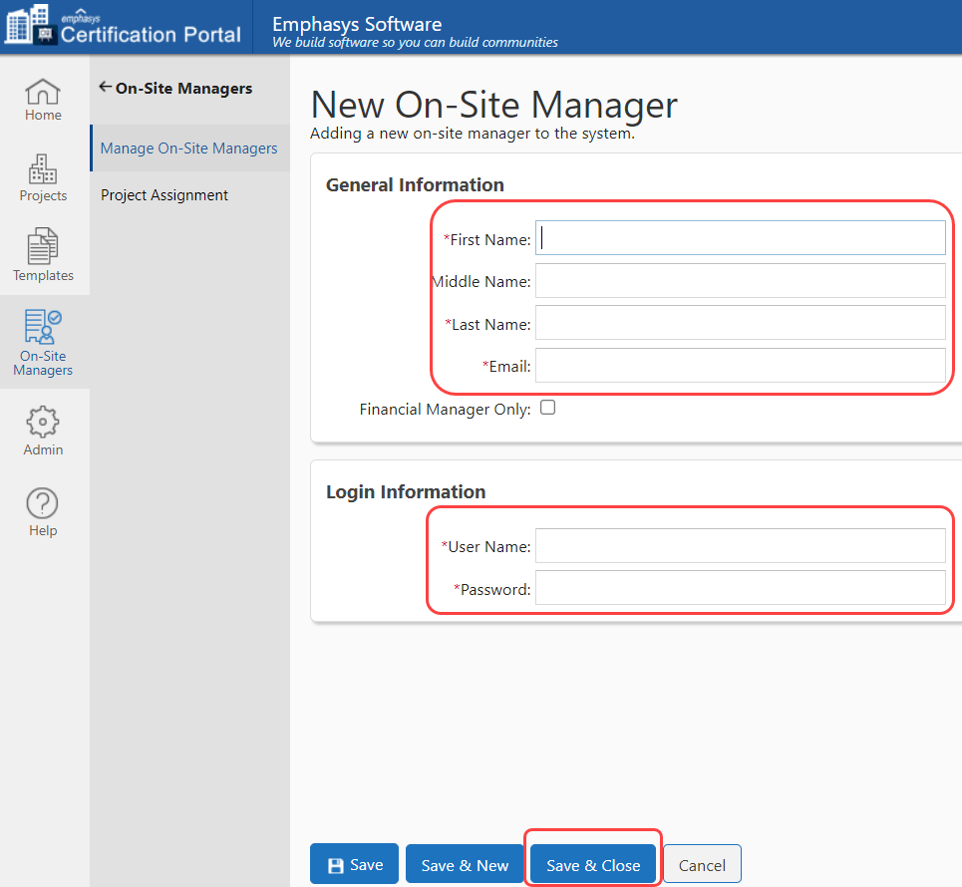

Once you have added in the On-Site Manager, go back into Project Assignment and update:


