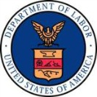
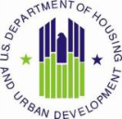



Davis-Bacon & Related Acts 1st Payroll Check List
Provide Wage Determination issued by the Department of Labor (DOL)
Ensure a fully executed contract with Subcontractor has been signed
Provide DBRA Subcontractor Certification fully executed.
Provide DBRA Weekly Report of Subcontractors on the Jobsite*
Provide fully executed Payroll Certification Forms first payroll should be numbered #1 or Initial.*
If someone other than owner, officer, principal of the company performing the work signs the payroll certification then an Authorization to Sign form must be included.
If apprentices are working on the jobsite all apprentice documents must be provided:
Certification of Registration
Apprentice Certification
Standards of Apprenticeship
Trade Schedule
Provide DBRA Employer Paid Fringe Benefit Form **
Provide DBRA Employee Deductions Form **

*Each Payroll thereafter
**In the future if additions or changes occur

