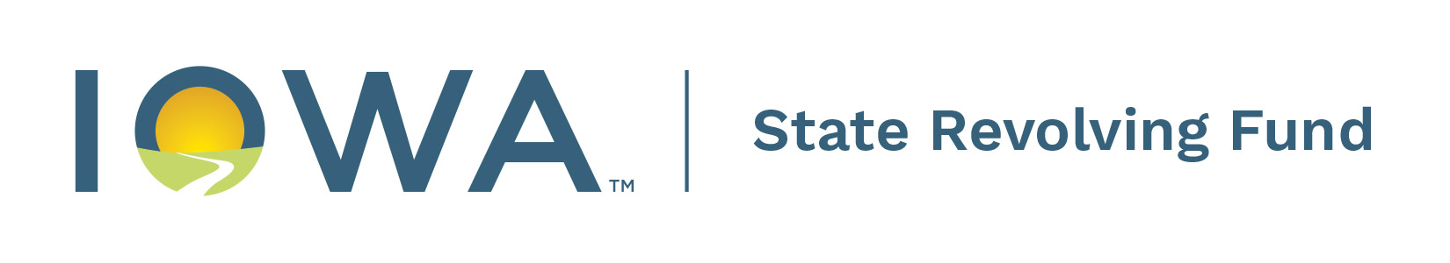
WATER RESOURCE RESTORATION (WRR) SPONSORED PROJECTS

SRF Bid Document Checklist for Applicants

When a sponsored project bid has been accepted, the party working with the contractor (e.g. consultant) prepares and submits a packet of documents to the DNR project manager. The DNR project manager will review the bid document package, and issue an eligibility letter stating the amount of the bid that is eligible for sponsored project reimbursement.

Please sign and complete this checklist with the bid document packet.

Consultant: |  | Date:

Sponsored Project Name: | (e.g. City practice WRRXX-XXX)
Associated CWSRF Number: |  | CS192

Permits
Indicate if all required state, federal, and local permits have been obtained
Yes, all required permits have been obtained and can be provided upon request

Check that the following documents are enclosed or have been previously submitted to DNR project manager
Engineering Documents
As-bid set of plans and specifications or statement by Engineer of no changes
Tabulation of bids with schedule of values as Excel document
Engineer’s written recommendation of award
Signed Maintenance plans for all practices
Recorded easement or deed if land acquisition is involved
Executed 28E agreement (if applicable).

Contractor Documents
Successful bid or bid proposal
Any addenda not previously submitted and bidder acknowledgment of all addenda
SRF Front End Attachments 1, 2, and 5 signed by selected contractor
Attachment 1: Certification of Non-Segregated Facilities Form
Attachment 2: Certification Regarding Debarment and Suspension Form
Attachment 5: Prohibition on certain telecomms and video services or equipment

The following documents need to be submitted to receive reimbursements from IFA. Please submit to SRF project manager as soon as executed:

Executed Contract
Notice to Proceed
Opinion of legal counsel certifying compliance with Iowa public bidding laws (for projects that award construction contract after October 1, 2023)

For more information, please contact your DNR SRF project manager

