What is a Floodway?
A "Regulatory Floodway" means the channel of a river or other watercourse and the adjacent land areas that must be reserved in order to discharge the base flood without cumulatively increasing the water surface elevation more than a designated height.
A floodway is more expansive than the riverbed or current water level. A floodway is typically less expansive than the area designated as Zone A or “100 year floodplain”.
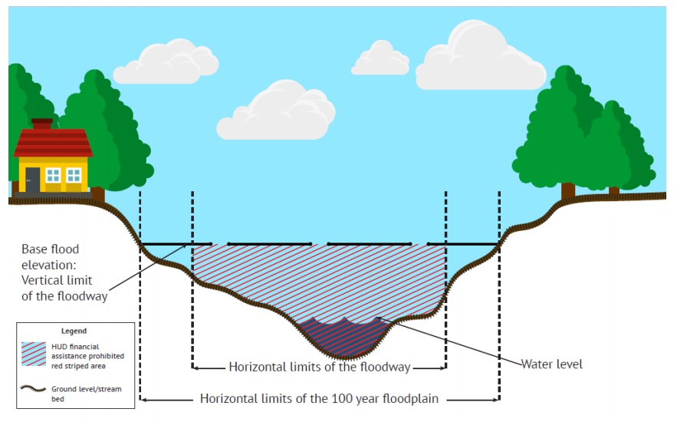
How to find a floodway on a FEMA map? Online maps can be found here: https://msc.fema.gov/portal/home
- On newer FEMA maps, floodways will be designated as red and blue cross hatch:
- On older FEMA maps, the area will be marked as Zone A and further investigation will need to be completed by contacting the engineer or DNR to determine the actual floodway.
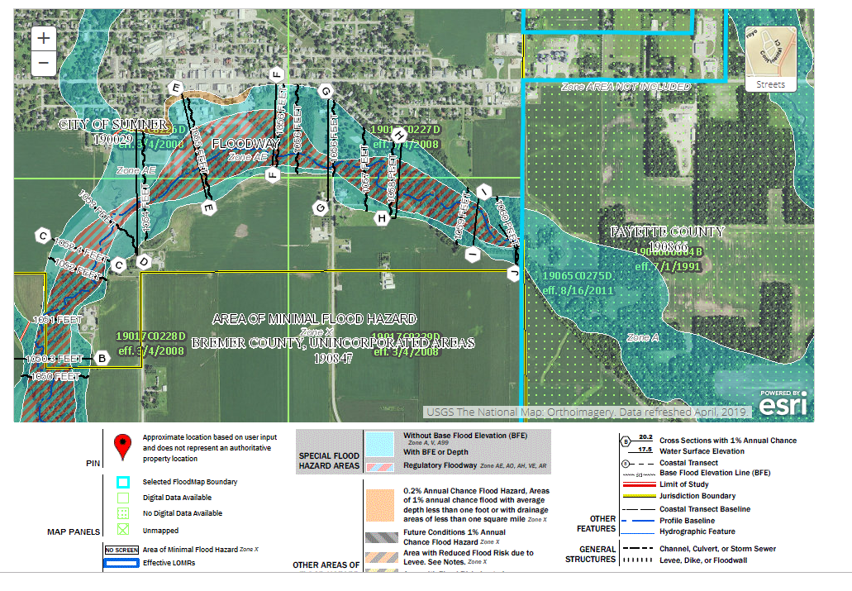
The difference between older and new maps can be seen in the FEMA map below:

What does this mean to my CDBG project?
- HUD prohibits financing ANY type of structure in the floodway unless it is a functionally depended use (bridge, warf, etc) or a floodplain function restoration activity.
- In some cases, linear infrastructure is allowed if the project results in no increase in upstream flood elevations. See HUD’s notice here: https://www.hud.gov/sites/dfiles/OCHCO/documents/17-13cpdn.pdf

